THESIS PROTOCOL

Effect of occlusal reduction on post operative pain and outcome of full pulpotomy performed in permanent mature mandibular molar teeth with symptomatic irreversible pulpitis and sensitivity to percussion: A Randomized Clinical Trial



Submitted to the Faculty
Division of Conservative Dentistry and Endodontics,
Centre for Dental Education and Research,
All India Institute of Medical Sciences,
New Delhi

In partial fulfilment of the requirement for the degree of
MASTER OF DENTAL SURGERY
(CONSERVATIVE DENTISTRY AND ENDODONTICS)

June 2024 NISARG DALAL
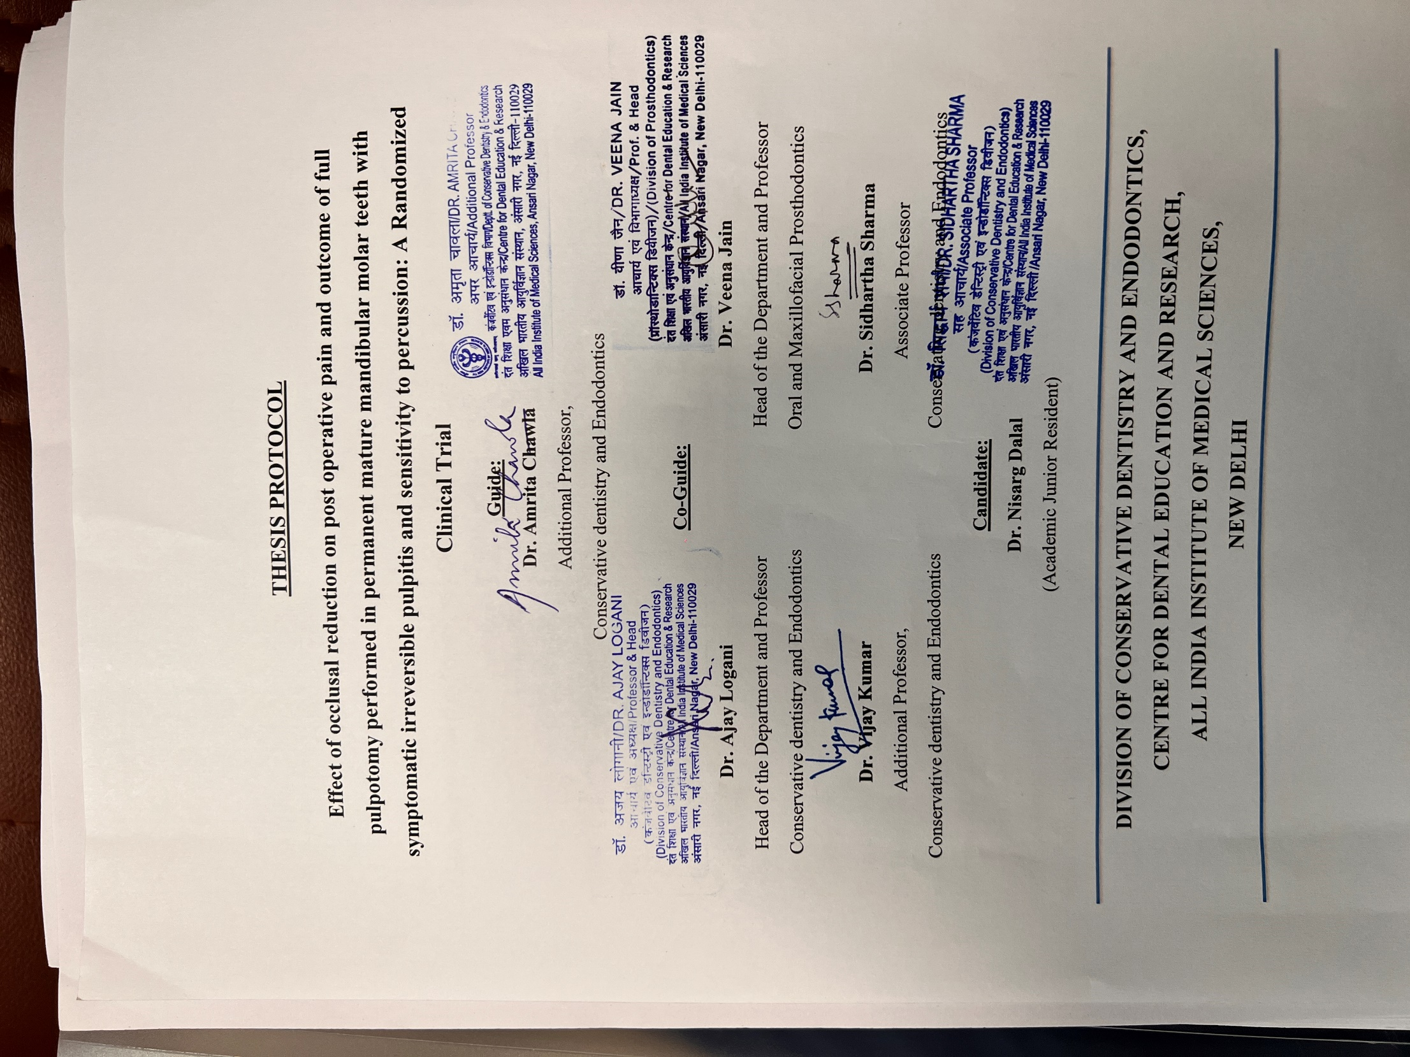

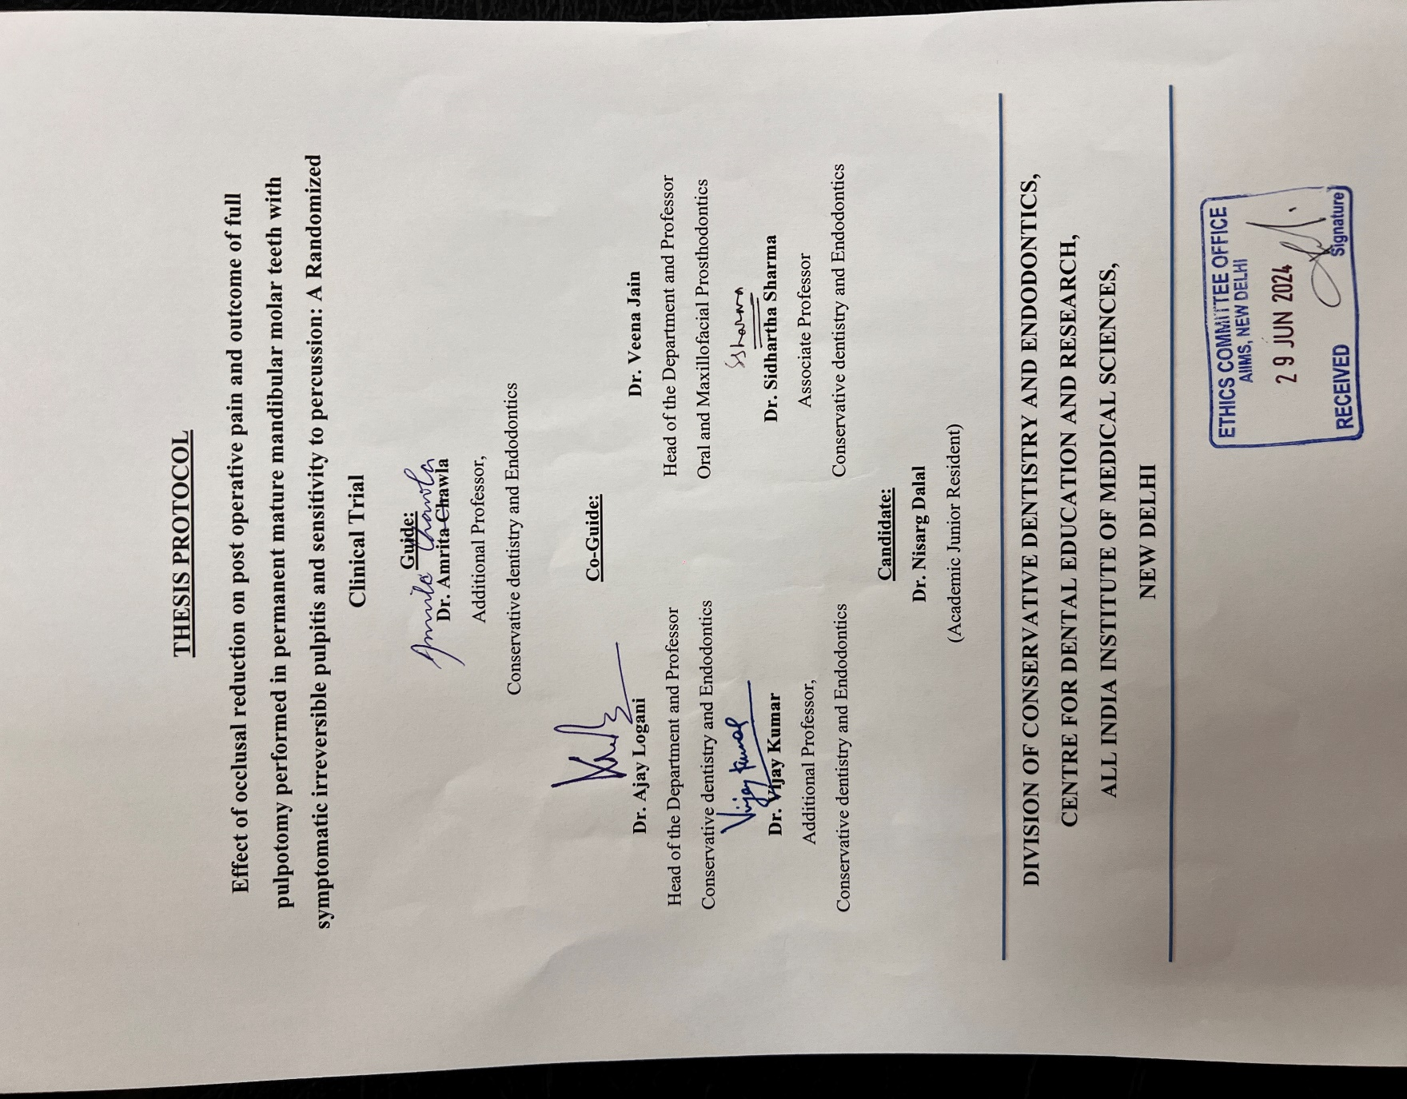

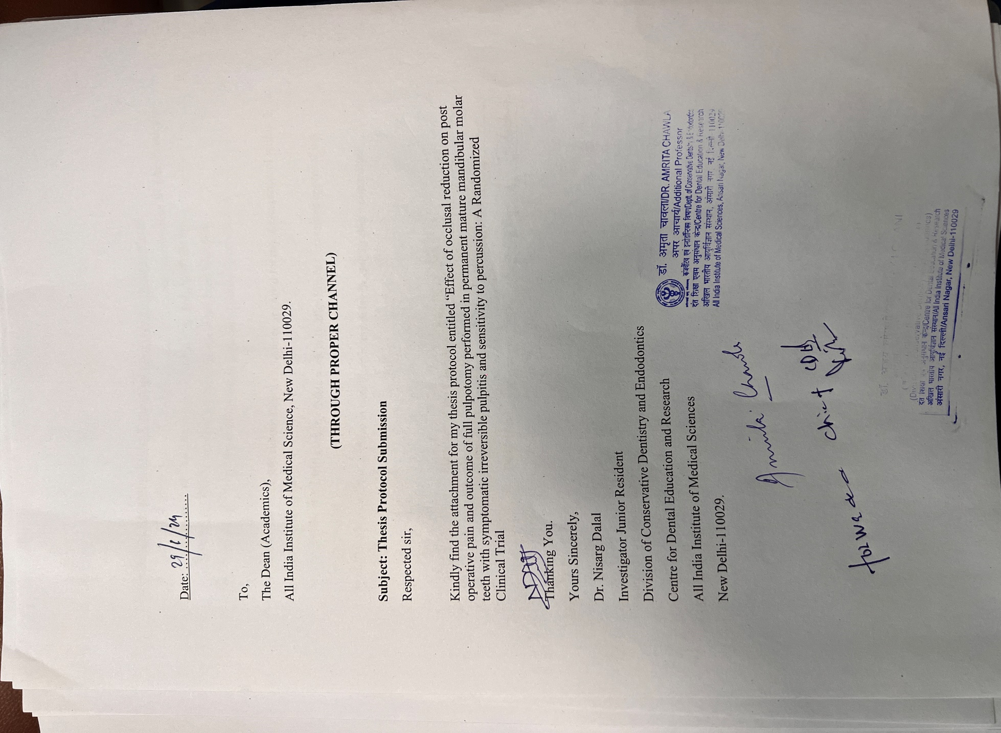

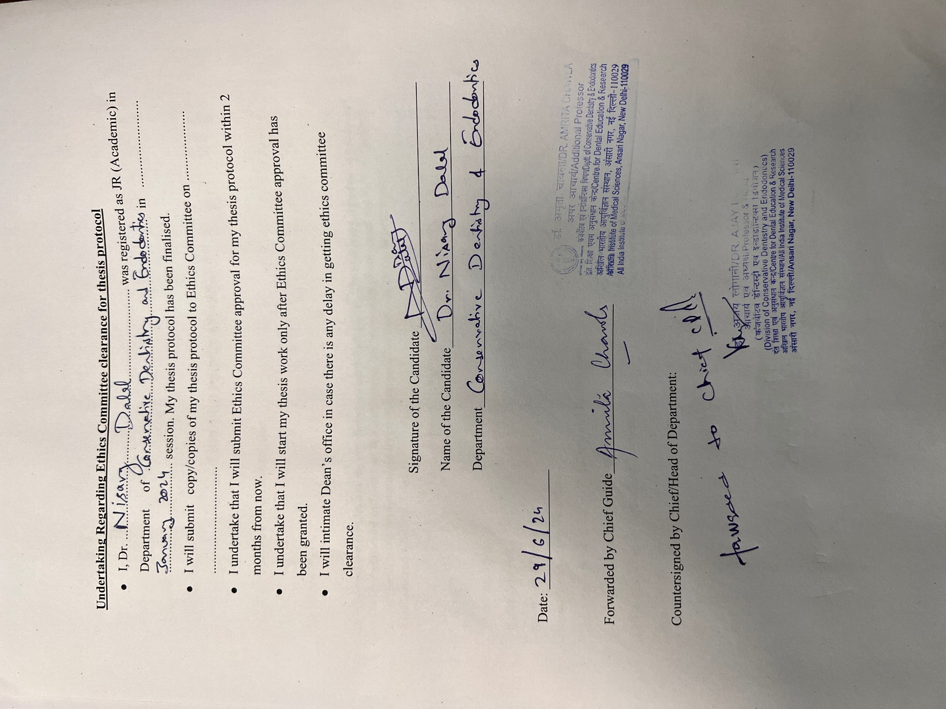

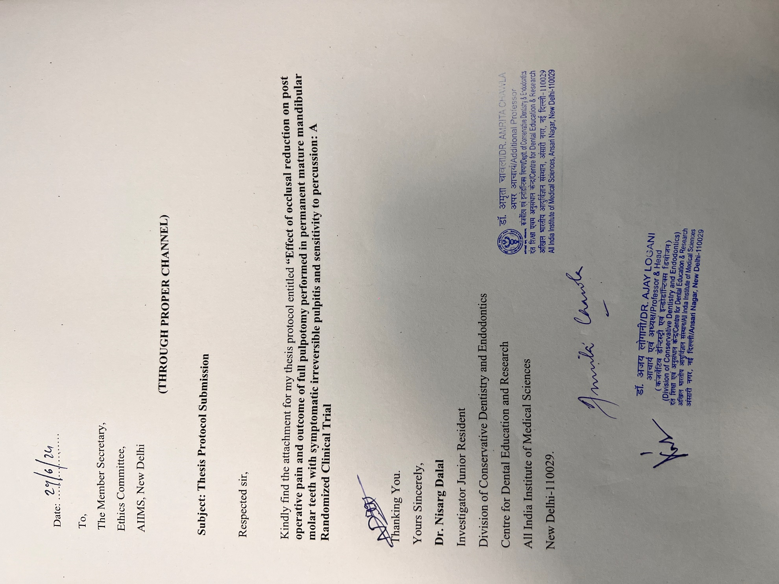
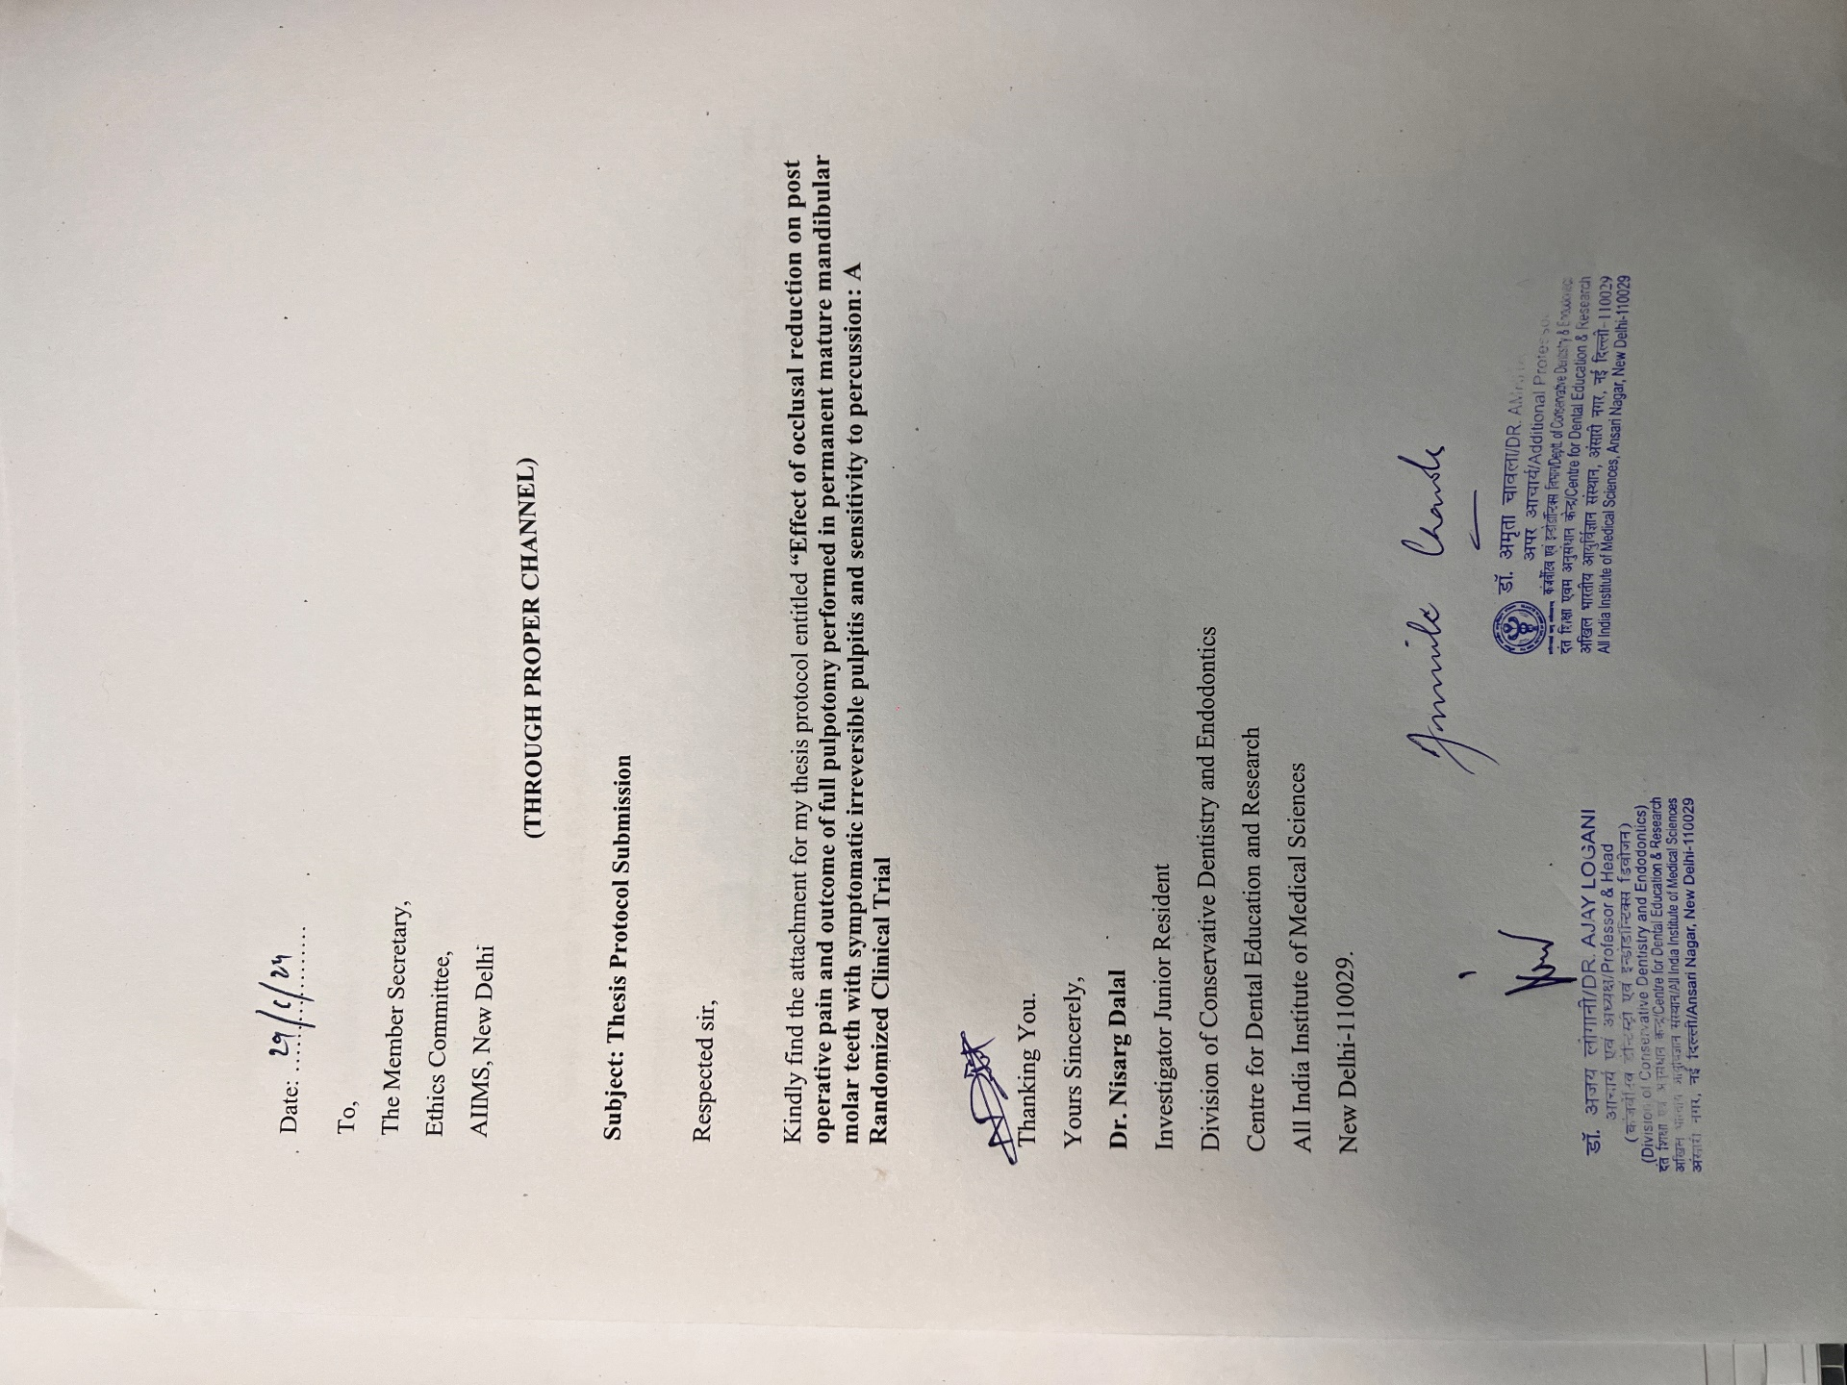
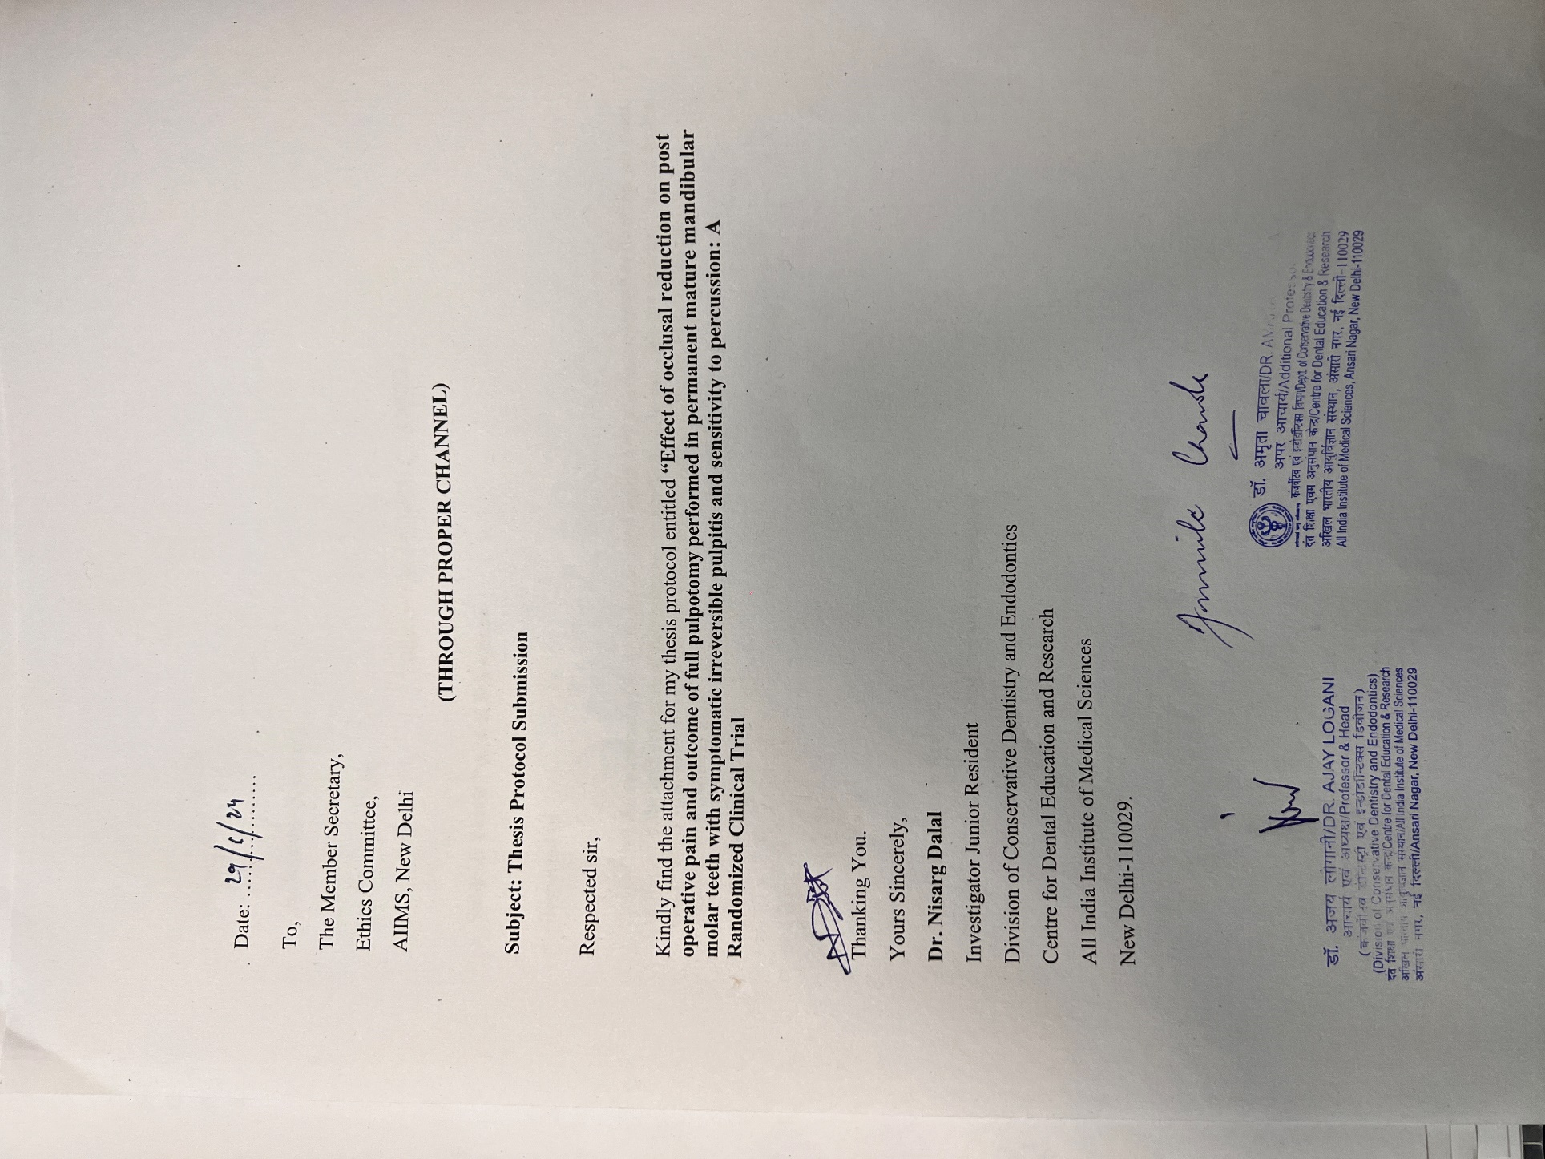
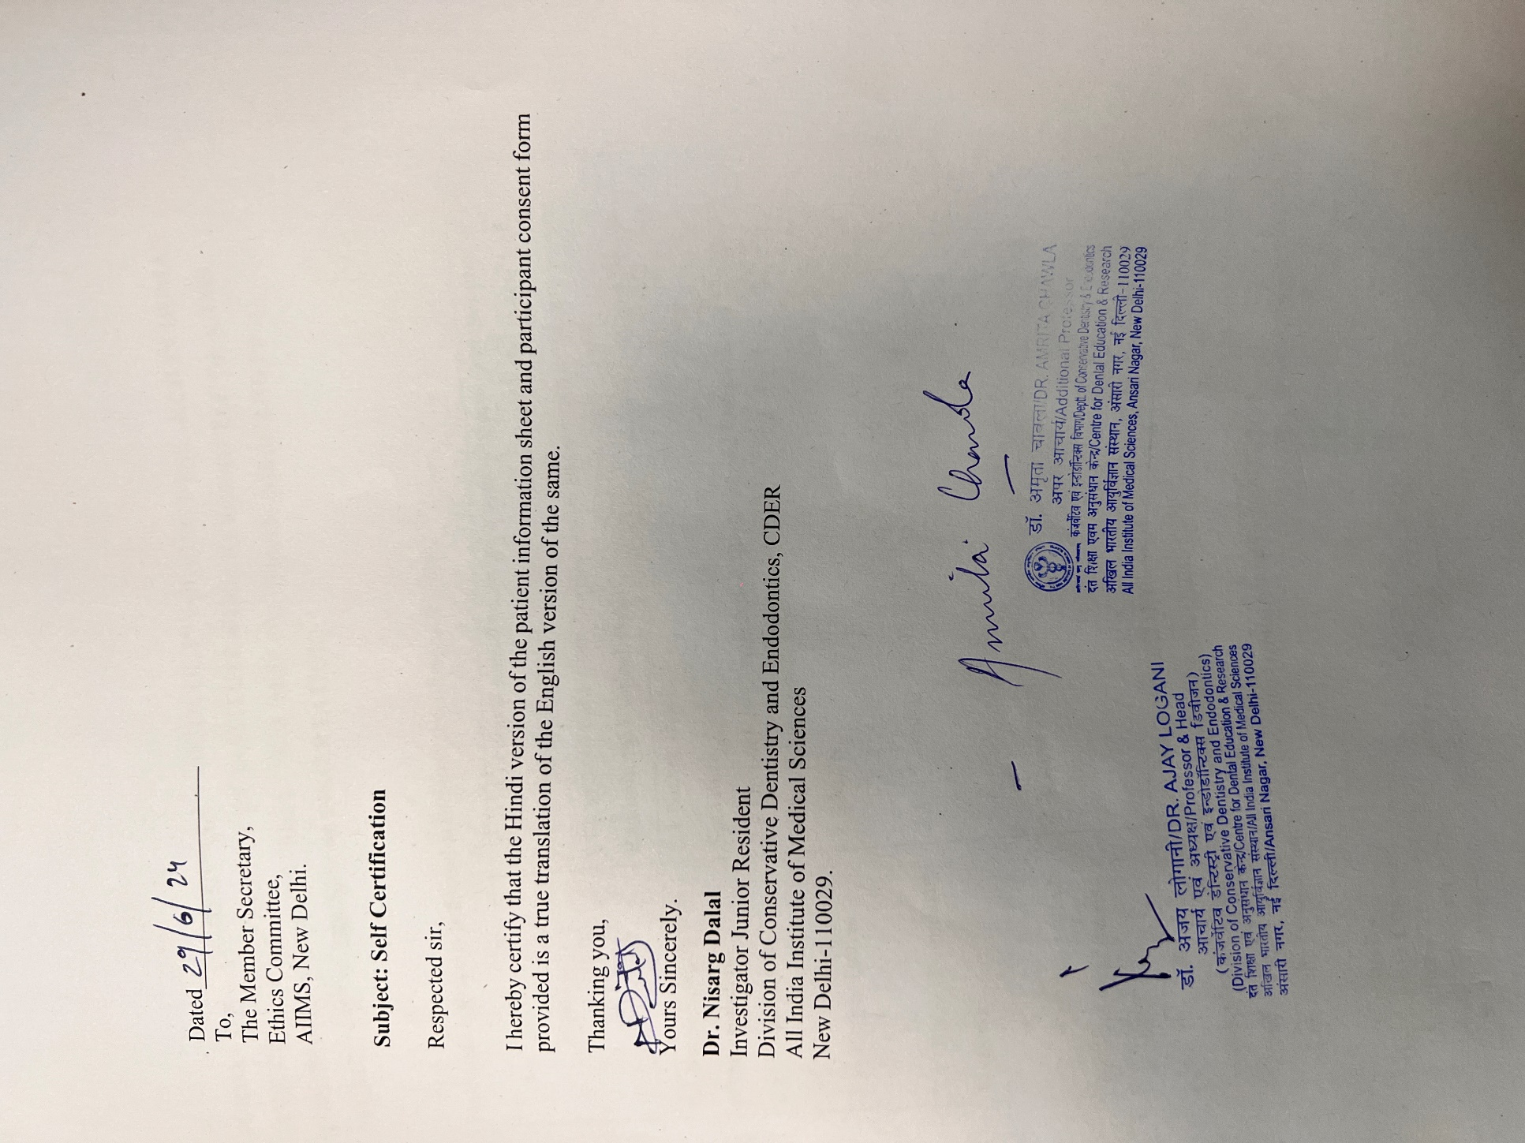
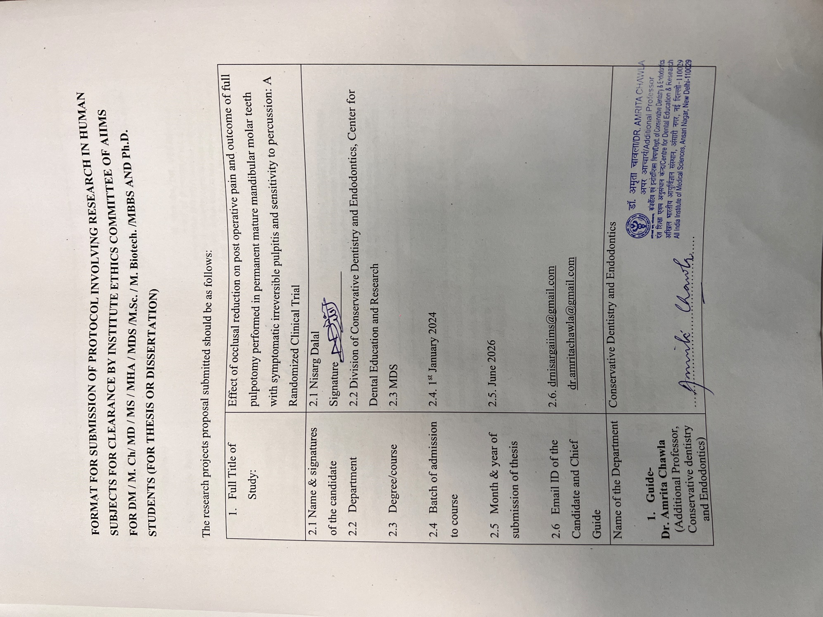
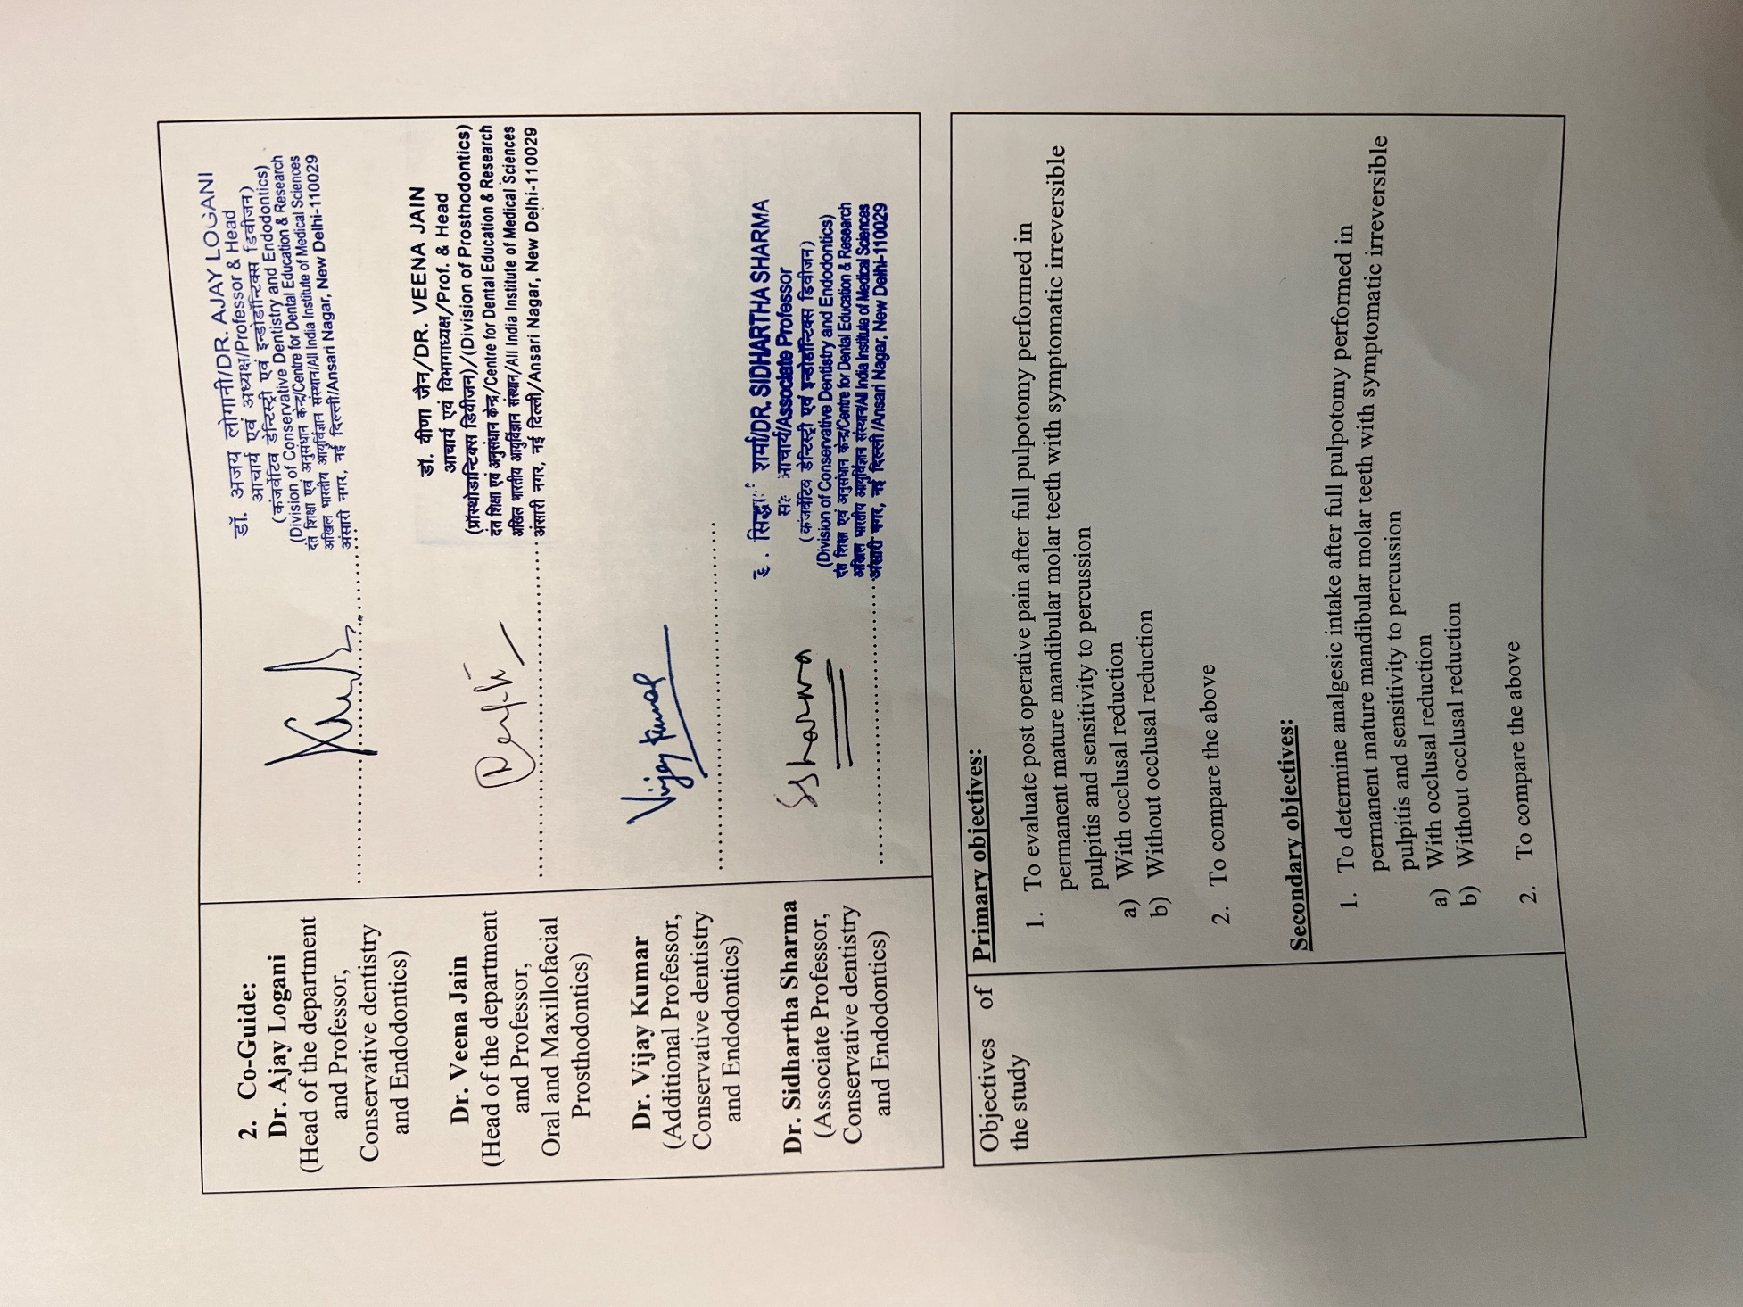
Objectives of the study | Primary objectives:  - To evaluate post operative pain after full pulpotomy performed in permanent mature mandibular molar teeth with symptomatic irreversible pulpitis and sensitivity to percussion  - With occlusal reduction  - Without occlusal reduction  - To compare the above  Secondary objectives:  - To determine analgesic intake after full pulpotomy performed in permanent mature mandibular molar teeth with symptomatic irreversible pulpitis and sensitivity to percussion  - With occlusal reduction  - Without occlusal reduction  - To compare the above  - To determine the outcome of full pulpotomy performed in permanent mature mandibular molar teeth with symptomatic irreversible pulpitis and sensitivity to percussion  - With occlusal reduction  - Without occlusal reduction  - To compare the above
5. Why this study is required? Please provide justification | - Pulpitis is a sequelae to an insult of dental pulp by microbial, chemical, or physical irritants (mechanical and thermal).¹ According to the American Association of Endodontics (AAE) consensus on diagnostic terminology, pulpitis can be either reversible or irreversible.² Teeth diagnosed with irreversible pulpitis are characterized by having spontaneous, intense and lingering pain (often lasting 30 seconds or more after stimulus removal) that is often triggered by thermal stimuli.²  - One study found that more than 50% of patients diagnosed with symptomatic irreversible pulpitis (SIP) presented with mechanical allodynia, indicating a significant incidence of percussion sensitivity in this condition.³⁷ Reportedly, pain due to irreversible pulpitis is the etiological factor for more than 45% of emergency dental visits. Mechanical allodynia in irreversible pulpitis may be attributed to various factors, including activation of pulpal mechanoreceptive nociceptive neurons, diffusion of inflammatory mediators or bacterial byproducts into the periradicular space, and central sensitization resulting from the activation of pulpal nociceptors.³⁷  - The preferred treatment of choice in such a scenario will be conventional non- surgical endodontic treatment (NSET) which has a success rate of 95% with an excellent prognosis.⁶ However, a small proportion of patients may still experience post-operative pain following root canal procedure, prevalence of which ranges from 3% - 58% ^{8,10}. One of the many reasons resulting in post operative pain following NSET is due to persistent sensitivity to percussion. Occlusal reduction is a technique that has shown promising results for managing postoperative pain by addressing occlusal discrepancies and managing percussion sensitivity.⁹  - Occlusal reduction involves the intentional reduction of the occlusal surface of the tooth to achieve evenly balanced and distributed occlusal forces across the dental arch.^{9,11} Reducing occlusal contacts may lower the mechanical stimulation of peripheral nociceptor terminals which are believed to decrease pain levels and the effects of mechanical allodynia and relieve the symptoms of percussion sensitivity.^{9,12}  - It is important to note that the effectiveness of occlusal reduction in reducing post-operative pain may vary depending on individual patient factors, the specific diagnosis of the tooth being treated, pre operative pain score, and periapical status of the tooth.¹⁴ Study by Ahmed et.al.,(2020) showed that occlusal reduction was associated with significantly less pain intensity at 12h and 24h post-instrumentation. Additionally, the study found a decrease in postoperative analgesic intake in the occlusal reduction group, highlighting the potential benefits of this intervention in managing post-operative pain. Systematic reviews mentioned the potential benefit of occlusal reduction while mentioning the need for further high-quality clinical trials to better understand its role.^{9,11,12}  - In recent times, there has been a paradigm shift in treating teeth diagnosed of SIP with Vital Pulp Therapy (VPT). Pulpotomy is one of the minimally invasive treatment modalities under VPT. Based upon clinical and radiographic evaluation, two types of pulpotomy can be performed in teeth with SIP: Full and Partial pulpotomy.¹⁵ Full pulpotomy refers to the complete removal of the coronal pulp and application of a biomaterial directly onto the pulp tissue at the level of the root canal orifice(s), prior to placement of a permanent restoration.¹⁵ In cases of pulpotomy, where the coronal pulp is removed to treat irreversible pulpitis, the formation of tertiary dentin is observed at the site of the pulp exposure as a reparative process initiated by remaining radicular pulp.¹⁶  - The success rate of pulpotomy using Biodentine in young permanent teeth with carious exposure was reported to be 95% at 1-year follow-up.¹⁷ The study demonstrated high clinical and radiographic success rates, with most cases showing total pain relief with dentin bridge formation and healing of periapical rarefaction.¹⁷ Asgary S et al (2010)¹⁸ in their study compared postoperative pain relief after single visit NSET and pulpotomy and concluded that the mean pain intensity and duration were significantly lower in the full pulpotomy group.¹⁸ The literature thus indicates lower levels of post operative pain after pulpotomy was performed in teeth diagnosed with SIP. One study highlights a high success rate of patients undergoing full pulpotomy but varying levels of postoperative pain, with approximately one-third of patients reporting some degree of pain.²¹ Galani et.al. (2017) noted that 70% of patient following full pulpotomy had slight to moderate pain on 1st day and then from following day onwards reported no to very slight pain till fifth day after treatment. Notably, the study found that continued pain at the 3-month evaluation point was significantly associated with an unfavourable outcome of VPT, emphasizing the importance of monitoring postoperative pain as a predictor of treatment success.^{20,21}  - Our hypothesis is mechanical allodynia is one of the reasons for the occurrence of post operative pain in teeth with SIP and sensitivity to percussion treated with full pulpotomy, and by occlusal reduction the incidence of post operative pain may be minimized by relieving the tooth from mechanical allodynia. Until now there is no study in the literature which has evaluated the effect of occlusal reduction on post operative pain following full pulpotomy performed in permanent mature mandibular molar teeth with symptomatic irreversible pulpitis and sensitivity to percussion. Therefore, the current study aims to evaluate the effect of occlusal reduction on post operative pain and outcome of full pulpotomy performed in permanent mature mandibular molar teeth with symptomatic irreversible pulpitis and sensitivity to percussion.
6. Methodology | Sample size calculation  Sample size is calculated based study done by Taha et al (2023), considering the average pain score following pulpotomy to be 2.19 ± 3.25 during seven days and on assuming a small effective size of 0.15 (0.5/3.25) between Occlusal reduction and Non-occlusal reduction groups (i.e, 0.15 less in O.R.) with α=5%, power=90%, 5 follow-up including baseline and 10% dropout rate, the required sample size for this study was determined to be 80 (n = 40) using the G-Power software v3.1.9.4.  Randomisation: The data will be randomized into two distinct groups utilizing a variable block size approach (with block sizes of 2, 4, 6, 8, 10, 12 and 14) generated through the statistical software Stata. This randomization will ensure that the allocation ratio between the two groups remains 1:1, thereby maintaining balance and comparability between the intervention and control groups throughout the trial.  Group 1: Full pulpotomy With occlusal reduction (test group)  Selective grinding will be performed with Wheel diamond burs (MANI, Japan) under constant air-water coolant until the teeth reach 0% post-intervention relative percentage of the occlusal force as will be appreciated on the monitor screen with v10 of T-Scan running and will show a real-time decrease in relative percentage of occlusal force.  Group 2: Full pulpotomy Without Occlusal Reduction ( control group)  To simulate occlusal reduction, a high-speed handpiece under air-water coolant will be activated inside the patient’s mouth without contacting the tooth surface. A post operative occlusal scan by T-Scan Novus will be done in the same manner as earlier to confirm no difference in the percentage of relative occlusal force.  Blinding: The participants would be blinded (single blinded study)  Inclusion criteria:  - Systemically healthy patients (ASA I & II) with age range between 18 to 40 years.  - Extremely deep carious (lesion penetrating ≥3/4th of dentine thickness) permanent mandibular first & second molars diagnosed clinically and radiologically with symptomatic irreversible pulpitis with sensitivity to percussion.  - Teeth with Positive response to EPT and cold test  - Teeth with restorable carious lesions.  - Radiographic examination showing periapical index score (PAI) of 1 or 2.  - Mandibular molars with antagonist tooth present  - Teeth which present with pre-operative pain intensity on NRS ≥4.  - Patients willing to have definitive prosthesis after full pulpotomy.  Exclusion criteria:  - Patient having a prior history of bruxism or clenching.  - Pregnant females  - History of analgesic intake or other drugs that might alter their pain during the last 24 hours preoperatively.  - History of allergic reactions to any of the medications and/or materials used.  - Tooth that has no contacts or premature contact.  - Acute periapical or periodontal abscess, greater than grade I mobility or pocket depth greater than 5 mm  Intra-operative exclusion criteria:  - Haemostasis after pulpotomy cannot be achieved within 8 minutes after the application of 2.5% NaOCl cotton pellet pack.  - No pulpal bleeding observed upon access opening.  - Clinical diagnosis changes to pulp necrosis.  6.4 Evaluation criteria:  Teeth will be evaluated clinically, radiographically and with T-Scan.  Clinical Criteria:  - Presence or Absence of pain.  - Presence or Absence of mobility.  - Presence or Absence of sinus/fistula.  - Response to percussion.  - Response to periapical palpation.  - Response to electric and cold test.  Radiographic Criteria –  Radiographic evaluation will be done according to periapical index score on intraoral periapical radiograph.  6.5 Clinical procedure:  Patients will be requested to rinse the oral cavity with 10 ml of 0.2% chlorhexidine digluconate (Aster-x, Sandika Pharmaceuticals Pvt. Ltd. New Delhi). Inferior alveolar nerve block (IANB) (Lox 2%, Neon Lab., New Delhi) will be administered to anaesthetize the concerned tooth/teeth. After 15 minutes, the tooth will be subjected to EPT (Sybron Endo Vitality Scanner 2006, Sybron Endo). A negative response would ensure a successful nerve block.  Once anesthesia has been achieved, a pre-operative occlusal analysis will be taken with T-Scan NOVUS (T-Scan Novus, Teckscan, Norwood, Massachusetts, U.S.A.) and pre-operative percentage of relative occlusal force between the tooth to be treated and its opposing tooth in centric occlusion and right and left lateral excursion will be noted. The test will be repeated several times and an average score will be obtained. The tooth to be treated will then be isolated with rubber dam. The carious lesion will be removed and any missing proximal wall will be restored with composite resin. Access to the pulp chamber will be gained using a round diamond bur (# 1013, Microdont, Sao Paulo, Brazil) operated at high speed under air-water coolant. Visual inspection will be done to observe the presence of bleeding pulp tissue to confirm pulp vitality. The inflamed coronal pulp tissue will be removed using a bur till the level of canal orifice. A small cotton pellet moistened with 2.5% sodium hypochlorite will be applied at the orifices for 2 minutes and repeated up to 4 times if required; the time to achieve haemostasis was recorded. If bleeding still continues pulpectomy will be initiated and the case will be excluded from the study. Once haemostasis will be achieved, a bioceramic endodontic material Biodentine (SEPTODONT 58, rue du Pont de Créteil 94107 Saint-Maur-des-Fossés Cedex France) will be mixed according to the manufacturer’s instructions and placed in a 2-3 mm layer above the pulp tissue using MAP system and gently packed using a condenser. A layer of RMGIC (Vitrebond, 3M ESPE, St. Paul, mn, USA) will be placed and light-cured for 20 seconds. The tooth will finally be restored with resin composite (Tetric N-Ceram Bulk fill) following standard protocol and manufacturer instructions. Rubber dam will be removed after this step. The teeth will be randomly divided into two groups as:  Group 1: Full pulpotomy With occlusal reduction (test group)  Selective grinding will be performed with Wheel diamond burs (MANI, Japan) under constant air-water coolant until the teeth reach 0% post-intervention relative percentage of the occlusal force as will be appreciated on the monitor screen with v10 of T-Scan running and will show a real-time decrease in relative percentage of occlusal force.  Group 2 : Full pulpotomy Without Occlusal Reduction ( control group)  To simulate occlusal reduction, a high-speed handpiece under air-water coolant will be activated inside the patient’s mouth without contacting the tooth surface. A post operative occlusal scan by T-Scan Novus will be done in the same manner as earlier to confirm no difference in the percentage of relative occlusal force.  This will be followed by finishing and polishing that will be done with appropriate polishing cups and points (Shofu Dental Corporation, San Marcos CA, U.S.A) in both group 1 and group 2. After completing the procedure, an intraoral periapical radiograph will be taken as a record.  Patients in both the groups will be prescribed 10 tablets of Ibuprofen 600mg and advised to take it when experiencing severe post-operative pain.  .This randomized controlled trial (RCT) titled "Effect of Occlusal Reduction on Postoperative Pain and Outcome of Full Pulpotomy Performed in Permanent Mature Mandibular Molar Teeth with Symptomatic Irreversible Pulpitis and Sensitivity to Percussion" was conducted in adherence to the Consolidated Standards of Reporting Trials (CONSORT) guidelines.  6.6. Study design –Randomized Clinical Trial  6.7. Dosages of drug- 600mg Ibuprofen 8 hourly in case of pain  6.8 Duration of the treatment: 1 year  6.9 Follow up  Clinical follow up  One year follow up period with recall at 1st day, 7th day 3rd month, 6th month and 12th month.  Radiographic follow up  One year follow up period with recall at 6th month and 12th month.  6.10. Investigation specifically related to Protocols – Four digital intraoral periapical radiographs will be included.  6.11 Permission to use copyrighted - Not applicable  6.12 Other - Not required
7. Permission from Drug Controller General of India (DCGI) | 1. Required 2 √ Not required  3. Received 4. Applied when:
7. Permission from Drug Controller General of India (DCGI) | 1. Required 2 √ Not required  3. Received 4. Applied when:
8. Permission from DGFT, if required | 1. Required 2 √ Not required  3. Received 4. Applied when:
9. a) Safety measures for proposed Interventions.  b) Results of relevant laboratory tests.  c) c) Results of studies in human. | The treatment would be performed under the guidance of the consultants. All precautions related to the procedure would be undertaken and would be performed under rubber dam in aseptic conditions. ALARA principle would be followed for the radiographic intervention.  - Not applicable.  Jostes JL, Holland GR. ²² in 1984 published one of the earliest research papers on the effect of occlusal reduction. In the study of 58 patients divided into two groups, there was no significant difference in total amount, maximum intensity or duration between the OR group and non-OR group. However, it was noted that patients who were not tender to the initial bite test tended to be more comfortable when the occlusion was left intact. Conversely, patients uncomfortable with the initial bite test experienced lower discomfort levels when the occlusion was relieved.  Creech JL 3rd, Walton RE, Kaltenbach R. ²³ in 1984 published a randomized controlled trial in which 49 patients receiving endodontic treatment were randomly assigned to either an occlusal relief group or a mock-occlusal relief group. The occlusal relief group had their teeth reduced out of occlusion, while the mock-occlusal relief group had minimal tooth structure removed from a nonfunctional cusp. Patients were followed up for 48 hours and the results indicated that spontaneous pain levels and pain from occlusal pressure were not significantly different between the two groups, but the levels of spontaneous pain were significantly related to pre-operative pain, irrespective of the intervention group.  Rosenberg PA et.al ¹⁴ in 1998 published a randomized controlled trial with 117 patients divided into three groups viz. total occlusal reduction, stimulated reduction and control (no reduction) and followed up for 48 hours post-instrumentation. Results emphasize the importance of considering these preoperative conditions such as preoperative pain, pulp vitality, percussion sensitivity, and absence of periradicular radiolucency when determining which patients are most likely to benefit from occlusal reduction. The presence of any one or more of these conditions indicates a potential benefit of occlusal reduction to reduce post-instrumentation pain.  Parirokh M et.al. ²⁴ in 2013 published an article aimed to investigate the effect of occlusal reduction on postoperative pain in patients with irreversible pulpitis and mild tenderness to percussion undergoing root canal treatment. `OR group had all occlusal contacts on the functional and non-functional cusps as well as on the marginal ridges reduced by 1 mm by using a diamond bur. The study also evaluated and compared post-operative analgesic intake and their effect on a scale that has a range of 0 to 2 (where 0: None or mild pain that does not require analgesic medication 1: Moderate pain that was fairly well controlled with analgesic medication and did not interfere with sleep or daily activities 2: Unbearable pain that was not controlled with analgesic medication and interfered with daily activities), Ibuprofen 600mg was prescribed every 6 hour if they felt pain. Patients were instructed to self-evaluate themselves for 6 days through printed form. The study found no significant difference in postoperative pain and analgesic intake between the OR group and the NOR group and therefore concluded that occlusal reduction may not be necessary in such cases to alleviate postoperative pain.  Arslan H et.al. ¹³ in 2017 published a study that investigated the influence of occlusal reduction on postoperative pain in teeth with symptomatic apical periodontitis using a computerized occlusal analysis system – T-Scan III for Windows. 39 subjects with severe pre-operative pain of (VAS >80mm) were divided into three equal groups: control group (no reduction), semi-reduction group (partial reduction), and full-reduction group (complete reduction). Instead of occlusal contact, pre- and post-operative relative percentage of occlusal force was taken in account for OR. No significant differences were found in postoperative pain levels and analgesic intake among the three groups at 1, 3, 5, and 7 days after treatment. The study concluded the occlusal reduction did not impact postoperative pain in teeth with symptomatic apical periodontitis.  Emara R.S. et.al., ²⁶ in 2019 published a randomized clinical trial investigated the effect of occlusal reduction on postoperative pain in mandibular posterior teeth with symptomatic irrversible pulpitis and apical periodontitis. The study included 44 patients with moderate to severe preoperative pain, divided into intervention and control groups. Postoperative pain levels decreased significantly over time in both groups, with lower pain scores in the OR group at various follow-up periods. The difference was significant at 12 hours post-treatment. There was no significant difference in postoperative analgesic intake between the groups. The study concluded that occlusal reduction may contribute to reducing postoperative pain in teeth with symptomatic irreversible pulpitis and symptomatic apical periodontitis.  Ahmed et al. ²⁷ in 2020 published a randomized controlled trial that aimed to evaluate the impact of occlusal reduction on post-treatment endodontic pain in mandibular posterior teeth with symptomatic irreversible pulpitis. 308 patients were divided equally into two groups (OR and non-OR) and at the end of the appointment were dismissed with sham analgesic containing powdered milk to be taken in case of pain. If pain persisted, the patient was instructed to contact the operator who would then prescribe an analgesic Ibuprofen 400 mg. Results showed that occlusal reduction was associated with significantly less pain intensity at 12h and 24h post-instrumentation. Additionally, the study found a decrease in postoperative analgesic intake in the occlusal reduction group, highlighting the potential benefits of this intervention in managing post-treatment pain.  Nguyen‐Nhon et.al., ¹¹ in 2019 published a systematic review and meta-analysis in which seven studies were analysed, with three included in the meta-analysis for post-operative pain assessment at 6 days, while the remaining studies underwent qualitative synthesis. The findings indicated that occlusal reduction potentially diminishes post-operative pain, particularly for teeth diagnosed with irreversible pulpitis, with an overall reduction in pain for patients presenting with irreversible pulpitis and/or symptomatic apical periodontitis. The review highlighted the need for future high-quality clinical trials to further elucidate the role of occlusal reduction in enhancing patient outcome following endodontic procedures.  Shamszadeh et al. ⁹ in 2020 systematic review and meta-analysis aimed to evaluate the efficacy of occlusal reduction in controlling post-operative endodontic pain in adults undergoing root canal therapy. The study included six randomized controlled trials with a total of 344 participants and found that occlusal reduction did not significantly reduce pain intensity scores at 12, 24 and 48 hours post-treatment compared to placebo. However, at the 72-hour mark, patients who received occlusal reduction showed a significant reduction in pain compared to the placebo group. The authors concluded that while occlusal reduction may not have a significant impact on pain control up to 2 days post-treatment, it could be beneficial in managing post-endodontic pain on the third day. Further research with larger sample sizes and standardized methodologies is recommended to provide more conclusive evidence on the effectiveness of occlusal reduction in post-endodontic pain management
10. Plans to withdraw standard therapy in research | Yes No √  Remarks:
11. Plan for provision of coverage for medical risk | These individual procedures are routinely done in  the department respectively. We do not anticipate  any risk due to the study per se.  However, management of any adverse events  developed during this study will be done as per the  protocol followed at the Division of Conservative  Dentistry and Endodontics, CDER, AIIMS.
12. How you will maintain the  Confidentiality of subject? | All the information collected in this study will be  kept strictly confidential, except as may be required  by law. The patient or his family will not be  identified by name, if results are published for  academic purpose after prior permission.
13. Costs Involved (Appx. in Rs.) | No charges will be taken from patients for the study.  The department will bear all the costs for the same  .
14. Participant Information Sheet (mark √ if yes) | Attached English version  Attached Hindi version  Certified that Hindi version is a true translation of English version.
15. Participant Informed Consent Form  (mark √ if yes) | Attached English version  Attached Hindi version  Certified that Hindi version is a true translation of English version.
16. Whether any work on this project has started or not? | (mark √ if yes, X if no) X  (Please enclose a separate certificate to this effect).
17.Attached documents  (If any) | 17.1 Covering letter, through proper channel.  17.2 Copy of the detailed protocol  17.3 Undertaking that the study shall be done in accordance with ICMR and GCP guidelines centres  17.5 Certificate/undertaking as mentioned in 16

18. CTRI resigtration | Trial acknowledgement number is REF/2024/06/087660

CONTENTS

Page No.

INTRODUCTION 1-4
REVIEW OF LITERATURE 5-11
RESEARCH QUESTION 12
LACUNAE IN LITERATURE 13
HYPOTHESIS 14
AIM AND OBJECTIVES 15
MATERIALS AND METHODS 16-32
REFERENCES 33-35
ANNEXURE – I (A & B) Participant information sheet 36-40
ANNEXURE – II (A & B) Participant informed consent form 41-43

TITLE
Effect of occlusal reduction on post operative pain and outcome of full pulpotomy performed in permanent mature mandibular molar teeth with symptomatic irreversible pulpitis and sensitivity to percussion: A Randomized Controlled Trial

INTRODUCTION
Pulpitis is a sequelae to an insult by microbial, chemical, or physical irritants (mechanical and thermal).¹ According to the American Association of Endodontics (AAE) consensus on diagnostic terminology, pulpitis can be either reversible or irreversible.² Pulpitis is deemed as reversible when the pulp can predictably return to normal conditions after the removal of the irritant stimulus.³
Teeth diagnosed with irreversible pulpitis are characterized by having spontaneous, intense and lingering pain (often lasting 30 seconds or more after stimulus removal) that is often triggered by thermal stimuli.² One study found that more than 50% of patients diagnosed with symptomatic irreversible pulpitis (SIP) presented with mechanical allodynia, indicating a significant incidence of percussion sensitivity in this condition.³⁷ Reportedly, pain due to irreversible pulpitis is the etiological factor for more than 45% of emergency dental visits.¹ However, as dental caries progresses, it destroys dentin and approaches the pulp with the inflammatory response becoming more intense increased in magnitude as the diseased state of the pulp progresses. The inflammatory condition of the pulp at this stage is changed to irreversible pulpitis.^{1,4} In irreversible pulpitis, the ability of pulp to return to its normal architecture becomes minimal even after removal of the irritant and hence requires partial or total excision of the affected pulp tissue.⁴ This condition can be subdivided into symptomatic and asymptomatic irreversible pulpitis².
According to guidelines given by AAE in 2013,¹ the teeth with symptomatic irreversible pulpitis are characterized by sharp pain upon thermal stimulus which is lingering (often 30 seconds or longer after stimulus removal), spontaneous (unprovoked pain) and may refer to surrounding anatomical structures. A clinical diagnosis is based on subjective and objective findings indicating that the vital inflamed pulp is incapable of healing¹. Mechanical allodynia in irreversible pulpitis may be attributed to various factors, including activation of pulpal mechanoreceptive nociceptive neurons, diffusion of inflammatory mediators or bacterial byproducts into the periradicular space, and central sensitization resulting from the activation of pulpal nociceptors.³⁷ This incapability of healing of pulp in symptomatic irreversible pulpitis is based on the strangulation theory which hypothesized that due to inflammation there is an increase in pulpal pressure in the low-compliant pulp from normal to higher magnitude.^{4,5} Theoretically, the tissue pressure may soon reach a magnitude that results in compression of the blood vessels which ultimately leads to pulp degeneration.^{1,3} The preferred treatment of choice in such a scenario will be conventional non-surgical endodontic treatment (NSET) which has a success rate of 95% with an excellent prognosis.⁶

The purpose of NSET is to completely remove the infected or inflamed pulp tissue, shape the canal space, and establish a bacteria-tight seal to promote healing and retain natural tooth function.³ The success rate of NSET depends on factors like proper diagnosis after correlation of clinical and radiographic features, extent of carious lesion, disinfection protocols, instrumentation, filling procedures, and post-treatment care.⁷ Research indicates success rates of NSET to vary between 86 - 97%.^{6–8} Criteria for a successful outcome are determined by the elimination of pain, presence of a bacteria-tight seal of the canal space, retention of the tooth, and preservation of natural tooth function.^{3,7} However, a small proportion of patients may still experience post-operative pain following root canal procedure, prevalence of which ranges from 3% - 58% ^{8,10}. An endodontically treated tooth with foreign root canal filling materials is biologically inferior to the original dental pulp because root canal filling materials lack biological immune defence mechanism and sensory nerve innervation. One of the many reasons resulting in post operative pain following NSET is due to persistent sensitivity to percussion following NSET, which is not addressed by the treatment. Additionally, the survival rate of endodontically treated teeth has been reported to be lower than that of vital teeth.¹⁰ Multiple factors which can be attributed towards the same include persistence of bacteria, inadequate filling of the canal, and iatrogenic procedural errors.⁸

Occlusal reduction is a technique that has shown promising result for managing postoperative pain by addressing occlusal discrepancies and mechanical allodynia.⁹ Occlusal reduction involves the intentional reduction of the occlusal surface of the tooth to achieve evenly balanced and distributed occlusal forces across the dental arch.^{9,11} Reducing occlusal contacts may lower the mechanical stimulation of peripheral nociceptor terminals which are believed to decrease pain levels and the effects of mechanical allodynia.^{9,12,37} By adjusting occlusal contacts, the goal is to create a more stable and balanced occlusion that promotes healing and reduces the likelihood of pain or sensitivity after dental procedures.¹³ It is important to note that the effectiveness of occlusal reduction in reducing post-operative pain may vary depending on individual patient factors, the specific diagnosis of the tooth being treated, pre-operative pain score, and periapical status of the tooth.¹⁴ Study by Ahmed et.al.,(2020) showed that occlusal reduction was associated with significantly less pain intensity at 12h and 24h post-instrumentation. Additionally, the study found a decrease in postoperative analgesic intake in the occlusal reduction group, highlighting the potential benefits of this intervention in managing post-treatment pain. Systematic reviews mentioned potential benefit of occlusal reduction while mentioning the need for further high-quality clinical trials to better understand its role.^{9,11,12}

However nowadays, an alternate definitive treatment that has been considered in teeth diagnosed with symptomatic irreversible pulpitis is pulpotomy.³ Based upon clinical and radiographic evaluation, two types of pulpotomy can be performed in teeth with SIP: Full and Partial pulotomy .¹⁵ Full pulpotomy refers to complete removal of the coronal pulp and application of a biomaterial directly onto the pulp tissue at the level of the root canal orifice(s), prior to placement of a permanent restoration.¹⁵ In cases of pulpotomy, where the coronal pulp is removed to treat irreversible pulpitis, the formation of tertiary dentin is observed at the site of the pulp exposure.¹⁶ Histologically, this tertiary dentin appears as a reparative dentin bridge that gradually forms over time, contributing to the sealing of the pulp chamber with calcium silicate bio-material and protecting the remaining vital pulp tissue.^{15,16} Additionally, histological analysis of teeth post-pulpotomy often reveals a reduction in inflammation within the pulp tissue as the reparative process progresses. The decrease in inflammation is indicative of the pulp's healing response to the treatment intervention, with the formation of tertiary dentin playing a key role in this regenerative process.^{4,16}
The success rate of full pulpotomy using Biodentine in young permanent teeth with carious exposure was reported to be 95% at 1-year follow-up.¹⁷ The study demonstrated high clinical and radiographic success rates, with most cases showing total pain relief with dentin bridge formation and healing of periapical rarefaction.¹⁷ Asgary S et al (2010)¹⁸ in their study compared postoperative pain relief after single visit NSET and pulpotomy and concluded that the mean pain intensity and duration were significantly lower in the full pulpotomy group.¹⁸ All patients in the pulpotomy group reported complete relief of pain at 18 hour post-operatively compared to 36 hour in NSET group, indicating that the patients experienced significant pain relief shortly after the treatment.¹⁸ In another study by Taha and Al-khatib¹⁹ (2022), full pulpotomy was performed in symptomatic permanent mature teeth with carious pulp exposure and the authors reported a high success rate over a 4-year follow-up period. The overall mean survival time of pulpotomy was 3.89 years, with cumulative survival rates of 98%, 97.4%, 93%, and 83.8% at 6 months and 1, 2, and 4 years, respectively.¹⁹ In another similar study where cases of irreversible pulpitis having moderate to severe levels of preoperative pain were treated with pulpotomy and NSET, the mean pain score after full pulpotomy was significantly lower than the mean pain score after NSET on day 1 post-operatively. At subsequent follow-up intervals of day 2, 3, and 5, the pain levels were still lower with no statistically significant difference. The full pulpotomy group had a significantly lower percentage of patients taking analgesics after treatment than the NSET group.²⁰ The literature thus indicates lower levels of post operative pain after pulpotomy was performed in teeth diagnosed with SIP. However, a study by Shallal-Ayzin et al., (2021) highlights a high success rate of patients undergoing full pulpotomy but varying levels of postoperative pain, with approximately one-third of patients reporting some degree of pain.²¹ Galani et.al. (2017)³⁵ noted that 70% of patient following full pulpotomy had slight to moderate pain on 1st day and then from following day onwards reported no to very slight pain till fifth day after treatment. In another similar study result showed that patients experienced mild to moderate pain in the immediate postoperative period, which typically resolved within a week.²¹ Notably, the study found that continued pain at the 3-month evaluation point was significantly associated with an unfavourable outcome of VPT, emphasizing the importance of monitoring postoperative pain as a predictor of treatment success.^{20,21}

Our hypothesis is mechanical allodynia is one of the reasons for the occurrence of post operative pain in teeth with SIP and sensitivity to percussion treated with full pulpotomy, and by occlusal reduction the incidence of post operative pain may be minimized by relieving the tooth from mechanical allodynia. Until now, no study in the literature has evaluated the effect of occlusal reduction on post operative pain following full pulpotomy performed in permanent mature mandibular molar teeth with symptomatic irreversible pulpitis and sensitivity to percussion. Therefore, the current study aims to evaluate the effect of occlusal reduction on post operative pain and outcome of full pulpotomy performed in permanent mature mandibular molar teeth with symptomatic irreversible pulpitis and sensitivity to percussion.
This Randomized Controlled Trial (RCT) titled "Effect of Occlusal Reduction on Postoperative Pain and Outcome of Full Pulpotomy Performed in Permanent Mature Mandibular Molar Teeth with Symptomatic Irreversible Pulpitis and Sensitivity to Percussion" was conducted in adherence to the Consolidated Standards of Reporting Trials (CONSORT) guidelines.
REVIEW OF LITERATURE

A systematic review was performed with the search of PubMed. The Medline database was used as an electronic search source. The search was limited to articles in the English language published till March 2023. The key word “Occlusal reduction” “Post operative pain” “Pulpotomy”, “Root canal treatment”, “Pulpitis”, “Permanent dentition”, were used as control search headings (MeSH). The free text search words “irreversible pulpitis”, “permanent teeth”, “outcome”, “management”, “analgesic intake”, “T-Scan” were later used and combined with previous search results. Full texts were obtained for relevant articles after screening the abstract. The cross-references were checked and suitable articles were also included in the literature review.
The review of literature will be dealt under the following headings:
- Effects of occlusal reduction on the management of post-operative pain following NSET
- Comparison of post-operative pain and success rate in teeth diagnosed of SIP treated with Full pulpotomy and NSET.

1. Effects of occlusal reduction on post-operative pain following NSET.

Jostes JL, Holland GR. ²² in 1984 published one of the earliest research papers on the effect of occlusal reduction. In the study of 58 patients divided into two groups, there was no significant difference in total amount, maximum intensity or duration between the OR group and non-OR group. However, it was noted that patients who were not tender to the initial bite test tended to be more comfortable when the occlusion was left intact. Conversely, patients uncomfortable with the initial bite test experienced lower discomfort levels when the occlusion was relieved.

Creech JL 3rd, Walton RE, Kaltenbach R. ²³ in 1984 published a randomized controlled trial in which 49 patients receiving endodontic treatment were randomly assigned to either an occlusal relief group or a mock-occlusal relief group. The occlusal relief group had their teeth reduced out of occlusion, while the mock-occlusal relief group had minimal tooth structure removed from a nonfunctional cusp. Patients were followed up for 48 hours and the results indicated that spontaneous pain levels and pain from occlusal pressure were not significantly different between the two groups, but the levels of spontaneous pain were significantly related to pre-operative pain, irrespective of the intervention group.

Rosenberg PA et.al ¹⁴ (1998) published a randomized controlled trial with 117 patients divided into three groups viz. total occlusal reduction, stimulated reduction and control (no reduction) and followed up for 48 hours post-instrumentation. Results emphasize the importance of considering these preoperative conditions such as preoperative pain, pulp vitality, percussion sensitivity, and absence of periradicular radiolucency when determining which patients are most likely to benefit from occlusal reduction. The presence of any one or more of these conditions indicates a potential benefit of occlusal reduction to reduce post-instrumentation pain.

Parirokh M et.al. ²⁴ in 2013 published an article aimed to investigate the effect of occlusal reduction on postoperative pain in patients with irreversible pulpitis and mild tenderness to percussion undergoing root canal treatment. `OR group had all occlusal contacts on the functional and non-functional cusps as well as on the marginal ridges reduced by 1 mm by using a diamond bur. The study also evaluated and compared post-operative analgesic intake and their effect on a scale that has a range of 0 to 2 (where 0: None or mild pain that does not require analgesic medication 1: Moderate pain that was fairly well controlled with analgesic medication and did not interfere with sleep or daily activities 2: Unbearable pain that was not controlled with analgesic medication and interfered with daily activities), Ibuprofen 600mg was prescribed every 6 hour if they felt pain. Patients were instructed to self-evaluate themselves for 6 days through printed form. The study found no significant difference in postoperative pain and analgesic intake between the OR group and the NOR group and therefore concluded that occlusal reduction may not be necessary in such cases to alleviate postoperative pain.

In the literature, the majority of the research done on occlusal reduction used articulating paper to determine the presence or absence of occlusal contacts but the use of articulating paper for occlusal analysis presents several disadvantages. Firstly, the interpretation of the marks left by the paper is highly subjective and can vary between individuals, leading to inconsistent assessments. Additionally, articulating the paper may not provide a comprehensive evaluation of occlusal contact simultaneity, potentially overlooking critical aspects of the occlusal relationship. The reproducibility of results obtained with articulating paper is also a concern, as they may not be easily replicated. Moreover, the paper lacks the sensitivity needed to detect subtle differences in occlusal contacts, which can be crucial for accurate analysis. The pressure applied during the biting process can further influence the results, introducing a degree of inaccuracy. Lastly, while the articulating paper offers qualitative information, it does not provide precise quantitative data on occlusal forces, limiting its utility in detailed occlusal analysis ^{13,25}.
The use of T-Scan for occlusal analysis offers several significant advantages over articulating paper. Firstly, T-Scan provides objective and quantitative data on occlusal contacts and forces, offering a more precise assessment compared to the qualitative information obtained from the articulating paper. It allows for real-time evaluation of occlusal contacts during mandibular movements, providing immediate feedback on occlusal dynamics. Additionally, T-Scan offers good reproducibility of surface measurements and the registration of relative forces, enhancing the reliability of the data obtained. Its high sensitivity enables the detection of primary contacts and excessive occlusal forces, allowing for the identification of subtle occlusal discrepancies. Unlike articulating paper, T-Scan is not affected by saliva, ensuring consistent and accurate results even in the presence of moisture. Furthermore, T-Scan provides a comprehensive evaluation of occlusal contact distribution, offering detailed insights into occlusal dynamics and potential areas of concern^{13,25}.

Arslan H et.al. ¹³ in 2017 published a study that investigated the influence of occlusal reduction on postoperative pain in teeth with symptomatic apical periodontitis using a computerized occlusal analysis system – T-Scan III for Windows. 39 subjects with severe pre-operative pain (VAS >80mm) were divided into three equal groups: control group (no reduction), semi-reduction group (partial reduction), and full-reduction group (complete reduction). Instead of occlusal contact, pre- and post-operative relative percentage of occlusal force was taken into account for OR. No significant differences were found in postoperative pain levels and analgesic intake among the three groups at 1, 3, 5, and 7 days after treatment. The study concluded the occlusal reduction did not impact postoperative pain in teeth with symptomatic apical periodontitis.

Emara R.S. et.al., ²⁶ in 2019 published a randomized clinical trial that investigated the effect of occlusal reduction on postoperative pain in mandibular posterior teeth with symptomatic irreversible pulpitis and apical periodontitis. The study included 44 patients with moderate to severe preoperative pain, divided into intervention and control groups. Postoperative pain levels decreased significantly over time in both groups, with lower pain scores in the OR group at various follow-up periods. The difference was significant at 12 hours post-treatment. There was no significant difference in postoperative analgesic intake between the groups. The study concluded that occlusal reduction may contribute to reducing postoperative pain in teeth with symptomatic irreversible pulpitis and symptomatic apical periodontitis.

Ahmed et al. ²⁷ in 2020 published a randomized controlled trial that aimed to evaluate the impact of occlusal reduction on post-treatment endodontic pain in mandibular posterior teeth with symptomatic irreversible pulpitis. 308 patients were divided equally into two groups (OR and non-OR) and at the end of the appointment were dismissed with sham analgesic containing powdered milk to be taken in case of pain. If pain persisted, the patient was instructed to contact the operator who would then prescribe an analgesic Ibuprofen 400 mg. Results showed that occlusal reduction was associated with significantly less pain intensity at 12h and 24h post-instrumentation. Additionally, the study found a decrease in postoperative analgesic intake in the occlusal reduction group, highlighting the potential benefits of this intervention in managing post-treatment pain.

Nguyen‐Nhon et.al., ¹¹ in 2019 published a systematic review and meta-analysis in which seven studies were analysed, with three included in the meta-analysis for post-operative pain assessment at 6 days, while the remaining studies underwent qualitative synthesis. The findings indicated that occlusal reduction potentially diminishes post-operative pain, particularly for teeth diagnosed with irreversible pulpitis, with an overall reduction in pain for patients presenting with irreversible pulpitis and/or symptomatic apical periodontitis. The review highlighted the need for future high-quality clinical trials to further elucidate the role of occlusal reduction in enhancing patient outcome following endodontic procedures.

Shamszadeh et al. ⁹ in 2020 systematic review and meta-analysis aimed to evaluate the efficacy of occlusal reduction in controlling post-operative endodontic pain in adults undergoing root canal therapy. The study included six randomized controlled trials with a total of 344 participants and found that occlusal reduction did not significantly reduce pain intensity scores at 12-, 24- and 48-hours post-treatment compared to placebo. However, at the 72-hour mark, patients who received occlusal reduction showed a significant reduction in pain compared to the placebo group. The authors concluded that while occlusal reduction may not have a significant impact on pain control up to 2 days post-treatment, it could be beneficial in managing post-endodontic pain on the third day. Further research with larger sample sizes and standardized methodologies is recommended to provide more conclusive evidence on the effectiveness of occlusal reduction in post-endodontic pain management

2. Comparison of post-operative pain and success rate in teeth diagnosed with SIP treated with Full pulpotomy and NSET.

Taha and Abdulkhader ¹⁷ in 2018 published a study involving 20 young permanent teeth with carious exposure and symptoms of irreversible pulpitis, full pulpotomy using Biodentine demonstrated a high success rate of 95% at the 1-year follow-up. Two days postoperatively, all patients reported complete relief of pain, indicating effective pain management. Clinical evaluations at 6 months and 1 year showed no spontaneous pain or discomfort in any of the cases, with continued root development and dentin bridge formation observed in some teeth. The study concluded that young permanent teeth with carious exposure can be successfully treated with full pulpotomy using Biodentine, even in cases with clinical signs and symptoms of irreversible pulpitis.

Taha and Abdelkhader ²⁸ included 64 permanent molar teeth with symptoms indicative of irreversible pulpitis. Preoperative diagnoses confirmed symptomatic vital pulps and periapical rarefaction in some cases. After pulpotomy using Biodentine canal orifices were sealed, and teeth were restored with resin composite or amalgam. Clinical and radiographic evaluations at 6 months and 1 year postoperatively showed a high success rate, with 98.4% and 100% clinical success, respectively. Radiographic success was 98.4% at 6 months and 100% at 1 year. Postoperative pain relief was significant, with 93.8% reporting complete pain relief after 2 days. The study concluded that full pulpotomy using Biodentine in adult patients with carious exposures and symptoms of irreversible pulpitis resulted in high success rates and significant pain relief, supporting the rationale for this treatment approach in such cases.

Taha and Al-Khatib ¹⁹ in 2022 published a study involving 100 symptomatic mature permanent teeth with carious pulp exposure who underwent full pulpotomy, the procedure demonstrated a high success rate over a 4-year follow-up period. The cumulative survival rates were 98%, 97.4%, 93%, and 83.8% at 6 months and 1, 2, and 4 years, respectively. Postoperatively, there was a significant improvement in pain severity, with 97% of patients reporting complete relief or mild pain within the first week after treatment. The study concluded that full pulpotomy in cariously exposed pulp of mature permanent teeth sustained a high success rate over 4 years, emphasising the importance of a good coronal seal for long-term survival.

Eghbal et.al., ²⁰ in 2020 published a study that included 550 participants with mature teeth and carious pulp exposure randomized into three groups: pulpotomy with mineral trioxide aggregate (PMTA), pulpotomy with calcium-enriched mixture (PCEM), and root canal treatment (NSET). The baseline characteristics and preoperative conditions were similar across the groups. Postoperative pain intensity was significantly reduced within 1 day after treatment and remained minimal over 7 days. The study concluded that pulpotomy with MTA or CEM and NSET provided comparable and effective postoperative pain relief in mature teeth with carious pulp exposure. Despite limitations such as the open-label design and lack of socioeconomic status assessment the large sample size and rigorous randomisation process enhanced the validity of the results.

McHugh et.al., ²⁹ 2023 systemic review on pulpotomy in permanent mature posterior teeth with moderate to severe pulpitis examined various diagnostic and prognostic factors influencing treatment outcome. Success rates of pulpotomy procedures varied among studies, with some reporting high success rates comparable to root canal treatment. Additionally, post-operative pain outcome were a significant focus, with evidence suggesting that pulpotomy resulted in lower postoperative pain in the short term compared to other treatments. These findings highlight the potential of pulpotomy as an effective and less painful alternative for managing moderate to severe pulpitis in adult teeth, emphasizing the importance of further research to optimize treatment protocols and enhance patient outcome.

Shallal-Ayzin et.al., ²¹ 2021 article presents a prospective analysis on the correlation between postoperative pain and vital pulp therapy (VPT). The study highlights a high success rate of VPT in maintaining pulp vitality, particularly in asymptomatic teeth with cariously exposed pulps. Patients undergoing VPT experienced varying levels of postoperative pain, with approximately one-third reporting some degree of pain. Most patients experienced mild to moderate pain in the immediate postoperative period, which typically resolved within a week. Notably, the study found that continued pain at the 3-month evaluation point was significantly associated with an unfavourable outcome of VPT, emphasizing the importance of monitoring postoperative pain as a predictor of treatment success

Alhilou et.al.,³⁰ 2023 published a systematic review on postoperative pain after emergency treatments for symptomatic irreversible pulpitis and symptomatic apical periodontitis in permanent dentition revealing that both pulpotomy and pulpectomy are effective options for alleviating endodontic pain. The 5 included studies indicated that pulpotomy and pulpectomy provide sufficient pain relief, with varying results on which treatment is more effective in reducing pain. The success rates of the treatments were relatively high, with pulpotomy showing success rates of 85% and pulpectomy 87%. Postoperative pain assessment using numeric rating scales and visual analogue scales showed inconsistent findings among the studies

Taha et.al., ³¹ in 2023 published a study that included 52 teeth divided equally between pulpotomy and NSET groups to compare their effectiveness in treating mature teeth with irreversible pulpitis. The success rates of both treatments were high, with 27 out of 29 teeth in each group showing success at the 1-year follow-up. Pulpotomy provided quicker pain relief post-operatively, with significantly lower mean pain scores compared to root canal therapy on day 1. Additionally, fewer patients in the pulpotomy group required analgesics after treatment. Overall, patients reported high satisfaction with both treatments, with pulpotomy scoring significantly higher in terms of time involved, intraoperative pain, pleasantness, and cost. The study concluded that pulpotomy can be a viable alternative to root canal therapy in certain cases of irreversible pulpitis, offering comparable success rates and improved post-operative pain outcome.

RESEARCH QUESTION
Does Occlusal reduction have an effect on post operative pain and outcome of full pulpotomy performed in permanent mature mandibular molar teeth with symptomatic irreversible pulpitis and sensitivity to percussion.

LACUNE IN LITERATURE
There is no study in the literature which has evaluated the effect of occlusal reduction on post operative pain and outcome of full pulpotomy performed in permanent mature mandibular molar teeth with symptomatic irreversible pulpitis and sensitivity to percussion.

HYPOTHESIS
There is no difference in post operative pain and outcome of full pulpotomy performed in permanent mature mandibular molar teeth with symptomatic irreversible pulpitis and sensitivity to percussion followed with or without occlusal reduction.

AIM:
To evaluate the effect of occlusal reduction on post operative pain and outcome of full pulpotomy performed in permanent mature mandibular molar teeth with symptomatic irreversible pulpitis and sensitivity to percussion.

OBJECTIVES:
Primary objectives:
- To evaluate post operative pain in Permanent Mandibular Molars with Symptomatic Irreversible Pulpitis and sensitivity to percussion treated with:
- Full pulpotomy with Occlusal reduction
- Full pulpotomy without Occlusal reduction
- To compare the above.

Secondary objectives:
      - To evaluate post operative analgesic intake in Permanent Mandibular Molars with Symptomatic Irreversible Pulpitis and sensitivity to percussion treated with:
- Full pulpotomy with Occlusal reduction
- Full pulpotomy without Occlusal reduction
      - To compare the above.
- To determine the outcome of full pulpotomy performed in Permanent Mandibular Molars with Symptomatic Irreversible Pulpitis and sensitivity to percussion:
- With occlusal reduction
- Without occlusal reduction

- To compare the above

MATERIALS AND METHODS

This study will be conducted in the Division of Conservative Dentistry and Endodontics, Centre for Dental Education and Research, All India Institute of Medical Sciences, New Delhi.
Ethical clearance will be obtained from the Institute Research Ethics Committee. Verbal information regarding the study aim, objectives, advantages / adverse effects of associated procedures and a written bilingual patient information sheet will be provided to the patient. All related queries will be explained to their complete satisfaction following which a written informed consent will be obtained.

Equipment and materials
- Intra-oral RVG 5200 digital imaging sensor (Carestream Dental, United States)
- Sensor positioning device (RINN XCP-ORA, Dentsply Int., New York, U.S.A)
- Dental rubber dam (Hygienic, Coltene / Whaledent Inc., Cuyahoga Falls, U.S.A)
- 0.2% Chlorhexidine digluconate (Aster-x, Sandika Pharmaceuticals Pvt. Ltd. New Delhi
- Irrigation solution, 5.25% sodium hypochlorite solution (Dentpro, Mohali, India)
- Irrigation solution, 0.9% normal saline (Zuche pharmaceuticals pvt. Ltd.)
- Calcium silicate-based cement/Biodentine (SEPTODONT 58, rue du Pont de Créteil 94107 Saint-Maur-des-Fossés Cedex France)
- Mineral Trioxide Aggregate (MTA) Plugger (Dentsply Sirona, Germany)
- Micro apical placement (MAP) system (Dentsply Sirona, Germany)
- Light cure glass ionomer cement (GIC) (Dentsply DeTreY GmbH, Konstanz, Germany)
- Light curing unit (Supra 1000 LED light curing unit, Asian power devices Inc., Henan, China)
- Dentsply Palodent V3 sectional matrix system with wedges (Dentsply, Germany)
- Microbrush application tips (Denmax, India)
- 37% phosphoric Acid (Etchant) (Solo Etch, Mediceptdental UK LTD, United Kingdom)
- 5th Generation Bonding agent (Kerr Optibond S, Kerr Corporation, west Collins, USA)
- Posterior restorative Composite resin (Tetric N-Ceram Bulk fill, Ivoclar Vivadent Ag)
- Composite instruments (TNCIFIM/L TNPLGH3 TNPLG0T TNPLG5A TNCFISS/M, Hu-Friedy, Chicago, USA)
- Composite finishing and polishing kit (Composite finishing kit, Shofu Dental Corporation, San Marcos CA, U.S.A)
- Dental Probe (Hu-Friedy, Chicago, U.S.A)
- Spoon excavator [EXC17WH, GDC (India) marketing co.]
- Articulating paper (Hanel. Coltene/ Whaledent, Germany)
- Tweezers (GPlus Dental Tweezer, gmt surgicals)
- Surgical glove (Surgicare Premium)
- Protective eye wear (Ultradent products, Inc.)
- Mouth masks (PM 0.3TMNanofiber, Romson)
- Wheel diamond Burs (MANI inc., Japan)
- T-Scan NOVUS handpiece, Tekscan inc.
- T-Scan NOVUS sensors
- T-Scan v10 software
- Laptop operating on Windows operating system

Sample size calculation:
Sample size is calculated based study done by Taha et al (2023), considering the average pain score following pulpotomy to be 2.19 ± 3.25 during seven days and on assuming a small effective size of 0.15 (0.5/3.25) between Occlusal reduction and Non-occlusal reduction groups (i.e, 0.15 less in O.R.) with α=5%, power=90%, 5 follow-up including baseline and 10% dropout rate, the required sample size for this study was determined to be 80 (n = 40) using the G-Power software v3.1.9.4.

Randomisation
The data will be randomized into two distinct groups utilizing a variable block size approach (with block sizes of 2, 4, 6, 8, 10, 12 and 14) generated through the statistical software Stata. This randomization will ensure that the allocation ratio between the two groups remains 1:1, thereby maintaining balance and comparability between the intervention and control groups throughout the trial.

Patient selection:
Patients referred to the Division of Conservative Dentistry and Endodontics at the Centre for Dental Education and Research, All India Institute of Medical Sciences, New Delhi for management of teeth exhibiting signs and symptoms of irreversible pulpitis will be screened.

Inclusion criteria:
- Systemically healthy patients (ASA I & II) with age range between 18 to 40 years.
- Extremely deep carious (lesion penetrating ≥3/4th of dentine thickness) permanent mandibular first & second molars diagnosed clinically and radiologically with symptomatic irreversible pulpitis with sensitivity to percussion.
- Teeth with Positive response to EPT and cold test
- Teeth with restorable carious lesions.
- Radiographic examination showing periapical index score (PAI) of 1 or 2.
- Mandibular molars with antagonist tooth present
- Teeth which present with pre-operative pain intensity on NRS ≥4.
- Patients willing to have definitive prosthesis after full pulpotomy.

Exclusion criteria:
- Patient having a prior history of bruxism or clenching.
- Pregnant females
- History of analgesic intake or other drugs that might alter their pain during the last 24 h preoperatively.
- History of allergic reactions to any of the medications and/or materials used.
Tooth that has no contacts or premature contact.
- Acute periapical or periodontal abscess, greater than grade I mobility or pocket depth greater than 5 mm

Intra-operative exclusion criteria:
- Haemostasis after pulpotomy cannot be achieved within 8 minutes after the application of 2.5% NaOCl cotton pellet pack
- No pulpal bleeding observed upon access opening.
- Clinical diagnosis changes to pulp necrosis.

Excluded teeth will be treated under standard treatment protocol.

Evaluation criteria:
A systematic approach of history taking, clinical and radiographic examination will be followed. The objective findings will be correlated with subjective details to formulate the definitive diagnosis.

History taking:
- Chief complaint
- History of present illness
- Pain characteristics
Nature of Pain | None | Mild | Moderate | Severe
Quality | Dull | Sharp | Throbbing | Constant
Onset | Stimulation Required | Intermittent | Spontaneous
Location | Localized | Diffuse | Radiating
Duration | Seconds/Minutes | Hours | Constant
Initiating Factors | Cold/Heat | Sweet | Spontaneous | Posture
Relieving Factors | Cold | Heat | Medications

PRE-OPERATIVE CLINICAL ASSESSMENT:
Extra-oral examination:
Extra-oral examination will be done to rule out any facial swelling, extra-oral sinus, palpable lymph nodes and facial asymmetry.

Intra-oral examination:
Palpation: Index finger will be used to palpate mucosa covering the roots and apices of teeth against the underlying cortical bone. The presence or absence of pain on palpation will be recorded as a positive or negative response respectively.

Percussion: Percussion will be performed by tapping the occlusal surface of teeth with a blunt end of an instrument. Percussion test will also be performed in horizontal and vertical direction to record the status of periodontal ligament inflammation. The intensity of pain/tenderness upon percussion will be recorded on a 11-point Numeric Rating Scale (NRS) with 0 representing one pain extreme (i.e. no pain) and 10 representing the other extreme (i.e. worst pain imaginable). The contralateral tooth will be taken as control. ²⁷
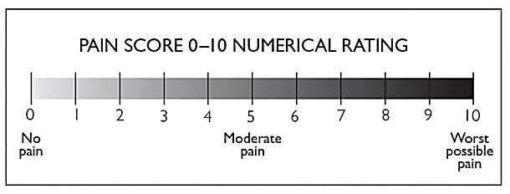
Figure 1: N.R.S. given by Downie et.al. ³²

Post operative percussion sensitivity test: Patients will be recalled upon and evaluated on 1st and 7th post operative day.

Pulp Sensibility Testing:
Thermal test:
Teeth will be isolated with cotton rolls and cold test will be performed by placing a small cotton pellet sprayed with endo-frost over the buccal cusp tip of the contralateral control tooth followed by the test tooth to evaluate pulp vitality. The result will be recorded as a positive or negative response.

Electric pulp test:
The teeth will be isolated with cotton rolls. The lip clip will be attached on the corner of the mouth and the tip of the testing probe coated with electrolyte gel will be placed in contact with the mesiobuccal cusp tip, cervical and lingual aspect of the tooth. The control tooth will be tested first in order to establish a baseline response and to inform the patient as to what a “normal” sensation is. The suspected tooth will be tested at least twice to confirm the preliminary result. The result will be recorded as a positive or negative response and EPT readings for positive response will also be noted.

Radiographic assessment:
The x-ray unit (ENDO-ACP, Villa system medical, Milano, Italy) would be set at 70 kV and 8mA with an exposure time of 0.12 secs. Long cone paralleling technique will be used. Patient exposure will be minimised by following ALARA (as low as reasonably achievable) principle. Pre-operative digital intraoral periapical will be exposed on a size- 1.5 CMOS RVG Sensor (Ezsensor, Vatech, Rayence Co., Ltd. 14, Samsung 1-Ro 1- Gil, Hwaseong-Si, Gyeonggi-Do, Korea). A customised polyvinyl 27 siloxane bite block held in RINN sensor positioning device will be used to standardize the pre-treatment and all subsequent follow-up radiographs. Inter-appointment, bite blocks will be stored in a refrigerator (Godrej Edge, New Delhi, India) at 4 degrees Celsius. Images will be saved in EzDent-I software and exported in jpg format to the patient’s folder and will be saved in the system storage.

OCCLUSAL ANALYSIS:
The pre-operative occlusal analysis will be done with the device T-Scan NOVUS (Tekscan, Norwood, Massachusetts, U.S.A.). The T-Scan Novus device setup consists of 3 major parts: T-Scan Novus handpiece, T-Scan Novus Sensor, and T-Scan v10 Software. Occlusal scan with T-Scan will record and display the percentage of relative occlusal force and their timing as the patient occludes the teeth to maintain maximum intercuspation and lateral excursions displayed live on a monitor screen. Patients will be taught to occlude their teeth properly with a wafer-thin sensor between them and the scan will be repeated several times and an average value of the relative percentage of occlusal force during maximum intercuspation and lateral excursions will be noted. The scan will be taken after the tooth to be treated shall be anaesthetized by the inferior alveolar nerve block.

Periapical Assessment:
Periapical status on the radiograph will be categorised using Periapical Index (PAI) given by Orstavik D et al (table 1).³³
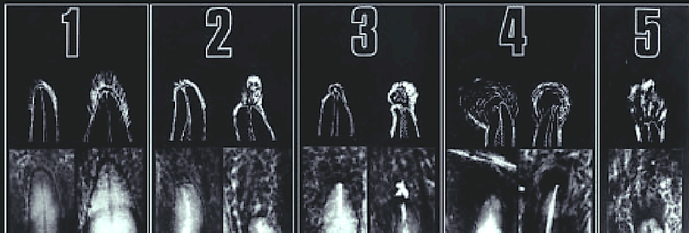
Figure 2: Reference radiographs, corresponding line drawings and their associated PAI³³
Score | Description
1 | Normal periapical structure
2 | Small change in bone structure
3 | Change in bone structure with some mineral loss
4 | Periodontitis with well-defined radiolucent area
5 | Severe periodontitis with exacerbating features
Table - 1: PAI score with their peri-apical radiograph appearance description ³³

ASSESSMENT OF PAIN INTENSITY:
Preoperative pain intensity will be recorded on an 11-point Numeric Rating Scale (NRS) with 0 representing one pain extreme (i.e. no pain) and 10 representing the other extreme (i.e. worst pain imaginable).³⁴
The preoperative pain score (NRS) will be recorded verbally. The respondent will be asked to indicate the numeric value on the segmented scale that best describes their pain intensity.

Figure 3: N.R.S. given by Downie³²

Post-operative pain will be recorded at 0 hours (baseline), 6th hour, 12th hour, 24hr, 2nd day, 3rd day till the 7th day after full pulpotomy in both the study groups.

Diagnosis:
Terminology and classification given by the American Association of Endodontists (AAE) will be used to ascertain the pulpal and periapical diagnosis (figure 3).²
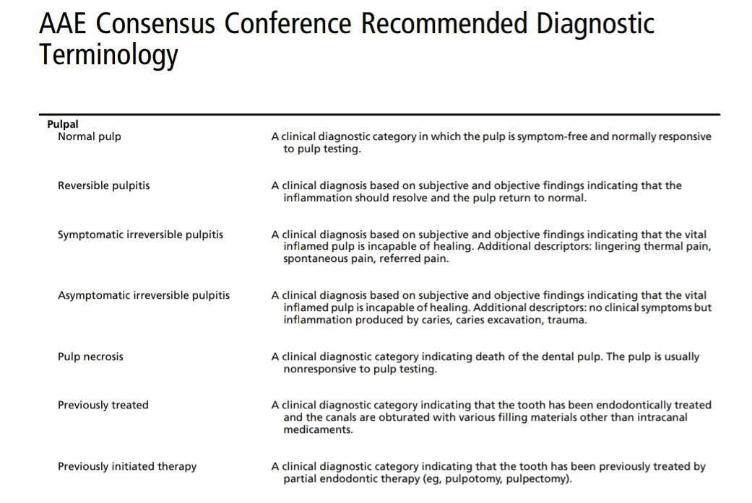
Figure 4: Terminology and classification given by the American Association of Endodontists (AAE)

Patients with an established diagnosis of symptomatic irreversible pulpitis and fulfilling the inclusion criteria will be recruited for the study.

CLINICAL PROCEDURE:
Patients will be requested to rinse the oral cavity with 10 ml of 0.2% chlorhexidine digluconate (Aster-x, Sandika Pharmaceuticals Pvt. Ltd. New Delhi). Inferior alveolar nerve block (IANB) (Lox 2%, Neon Lab., New Delhi) will be administered to anaesthetize the concerned tooth. After 15 minutes, the tooth will be subjected to EPT (Sybron Endo Vitality Scanner 2006, Sybron Endo). A negative response would ensure a successful nerve block.
Once anaesthesia has been achieved, a pre-operative occlusal analysis will be taken with T-Scan NOVUS (T-Scan Novus, Teckscan, Norwood, Massachusetts, U.S.A.) and pre-operative percentage of relative occlusal force between the tooth to be treated and its opposing tooth in centric occlusion and right and left lateral excursion will be noted. The test will be repeated several times and an average score will be obtained. The tooth to be treated will then be isolated with rubber dam. The carious lesion will be removed and any missing proximal wall will be restored with composite resin restorative material. Access to the pulp chamber will be gained using a round diamond bur (# 1013, Microdont, Sao Paulo, Brazil) operated at high speed under air-water coolant. Visual inspection will be done to observe the presence of bleeding pulp tissue to confirm pulp vitality. The inflamed coronal pulp tissue will be removed using a bur till the level of canal orifice. A small cotton pellet moistened with 2.5% sodium hypochlorite will be applied at the orifices for 2 minutes and repeated up to 4 times if required; the time to achieve haemostasis was recorded.³⁶ If bleeding dosen’t stop in 8 mins, pulpectomy will be initiated and the case will be excluded from the study. Once haemostasis will be achieved, a bio-ceramic endodontic material Biodentine (SEPTODONT 58, rue du Pont de Créteil 94107 Saint-Maur-des-Fossés Cedex France) will be mixed according to the manufacturer’s instructions and placed in a 2-3 mm layer above the pulp tissue using MAP system and gently packed using a condenser. A layer of RMGIC (Vitrebond, 3M ESPE, St. Paul, MN, USA) will be placed and light-cured for 20 seconds. The tooth will finally be restored with resin composite (Tetric N-Ceram Bulk fill) following standard protocol and manufacturer instructions. Rubber dam will be removed after this step. The teeth will be randomly divided into two groups as:
Group 1: Full pulpotomy With occlusal reduction (test group)
Selective grinding will be performed with Wheel diamond burs (MANI, Japan) under constant air-water coolant until the teeth reach 0% post-intervention relative percentage of the occlusal force as will be appreciated on the monitor screen with v10 of T-Scan running and will show a real-time decrease in relative percentage of occlusal force. All the patients of group 1 will be recalled at 6-month interval for the definitive prosthetic rehabilitation.

Group 2: Full pulpotomy Without Occlusal Reduction (control group)
To simulate occlusal reduction, a high-speed handpiece under air-water coolant will be activated inside the patient’s mouth without contacting the tooth surface. A post operative occlusal scan by T-Scan Novus will be done in the same manner as earlier to confirm no difference in the percentage of relative occlusal force.
This will be followed by finishing and polishing that will be done with appropriate polishing cups and points (Shofu Dental Corporation, San Marcos CA, U.S.A) for both group 1 and group 2. After completing the procedure, an intraoral periapical radiograph will be taken as a record.

Patients in both the groups will be prescribed 10 tablets of Ibuprofen 600mg and advised to take it when experiencing moderate-severe post-operative pain after consulting the doctor.

POST OPERATIVE EVALUATION:
All the patient at the end of the appointment will be dismissed with 10 tablets of Ibuprofen 600mg and will be instructed to take them 8 hourly in case of moderate - severe pain (NRS >6). The patient will be informed about the regular telephonic consult which will be done by the operator at 6 hours, 12 hours, 24 hours then daily till the 7th day at same time. The purpose of these consultations is to document the patient's pain severity and analgesic intake. If the patient experiences intense or excruciating pain, they will be asked to contact the doctor through a telephonic consultation to describe the severity of the pain. They will also be advised to take an additional tablet and visit the doctor. If the patient's discomfort is not alleviated, they will be classified as a failed case and will undergo pulpectomy treatment.

All patients will be followed through telephonic consult post-operatively will be evaluated for:
- Occurrence and intensity of postoperative pain.
Post-operative pain will be recorded on an 11-point NRS as done pre-operatively.
- Consumption and effect of analgesic for relieving postoperative pain if any.
To Analgesic consumption will be recorded for assessing the necessity, dosage (i.e., no. of tablets) and efficacy of analgesics using a 3-point scale based on Parirokh et al. ²⁴

RECALL VISITS:
Clinical follow up:
One year follow up period with recall at 1st day, 7th day 3rd month, 6th month and 12th month.
Patients will be evaluated clinically for pain and percussion sensitivity on 1st and 7th post operative day.
Patients of group 1 will be recalled at 6th month for definitive prosthetic rehabilitation.
Radiographic follow up:
One year follow up period with recall at 6th month and 12th month
Table 2: Scores for analgesic evaluation based on Parirokh et al. ²⁴
Score | Associated pain | Need and effect of analgesic
0 | No / Mild | Pain that does not require analgesic medication
1 | Moderate | Fairly well controlled with analgesic medication and did not interfere with sleep or daily activities
2 | Severe | Unbearable pain that was not controlled with analgesic  medication and interfered with daily activities

OUTCOME EVALUATION OF FULL PULPOTOMY ¹⁹ :
Outcome | Clinical criteria | Radiographic criteria
Success | - Patient is asymptomatic  - Absence of swelling, sinus tract  - Negative response to palpation and percussion test  - Positive response to cold test | - Normal peri-radicular architecture  - Absence of root resorption  - Absence of pulp canal obliteration
Failure | - Patient symptomatic  - Presence of swelling, sinus tract  - Positive response to palpation and percussion test.  - Negative response to cold test. | - Widening of periodontal ligament space  - Presence of apical or furcal radiolucency  - Presence of pulp canal obliterations.  - Presence of internal resorption

STATISTICAL ANALYSIS:
Appropriate statistical tests would be applied to the data generated
NAME: UHID:
AGE/SEX: DATE:
GROUP TIME:
PRE-OPERATIVE EVALUATION

CHIEF COMPLAINT:

HISTORY OF PRESENT ILLNESS:

ASSOCIATED TOOTH NUMBER:

SITE OF CARIES: Occlusal MO DO MOD

PAIN INTENSITY

PAIN CHARACTERISTICS:
Nature of Pain | None | Mild | Moderate | Severe
Quality | Dull | Sharp | Throbbing | Constant
Onset | Stimulation Required | Intermittent | Spontaneous
Location | Localized | Diffuse | Radiating
Duration | Seconds/Minutes | Hours | Constant
Initiating Factors | Cold/Heat | Sweet | Spontaneous | Posture
Relieving Factors | Cold | Heat | Medications

CLINICAL EVALUATION:
Palpation:


Percussion sensitivity:

PULP SENSIBILITY TEST
Thermal test:

E.P.T.:

OCCLUSAL SCAN with T-Scan
Percentage of relative occlusal force:

TELEPHONIC POST-OPERATIVE EVALUATION FORM
Hour/day of evaluation: 0hr 6thhr 12thhr 2ndday 3rdday 4thday 5thday 6thday
Time:

Scheduled call from the operator Emergency call from patient due to severe pain

Evaluation of PAIN INTENSITY:
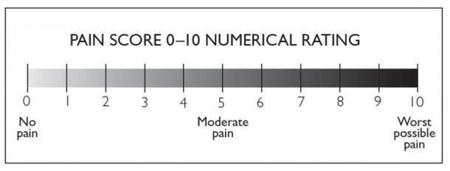

Evaluation of TYPE of Pain if any:

Spontaneous pain Pain upon chewing food and drinking hot/cold beverages

Evaluation of ANALGESIC CONSUMPTION:
Score | Associated pain | Need & Effect of Medicine
0 | NO / MILD | Pain that does not require analgesic medication
1 | MODERATE | Pain was fairly well controlled with analgesic medication and did not interfere with sleep or daily activities
2 | SEVERE | Unbearable pain that was not controlled with analgesic medication and interfered with daily activities, the patient contacts the operator.

Number(s) of tablets consumed in a day: _____
CLINICAL POST-OPERATIVE EVALUATION FORM
Day of evaluation: 1st day / 7thday Time:
Evaluation of PAIN INTENSITY:


Evaluation of TYPE of Pain if any:
Spontaneous pain Pain upon chewing food and drinking hot/cold beverages

Evaluation of ANALGESIC CONSUMPTION:
Score | Associated pain | Need & Effect of Medicine
0 | NO / MILD | Pain that does not require analgesic medication
1 | MODERATE | Pain was fairly well controlled with analgesic medication and did not interfere with sleep or daily activities
2 | SEVERE | Unbearable pain that was not controlled with analgesic medication and interfered with daily activities, the patient contacts the operator.

Number(s) of tablets consumed in a day: _____
Percussion sensitivity on 1st / 7th day:


Occlusal scan by T-Scan
Percentage of relative occlusal force:
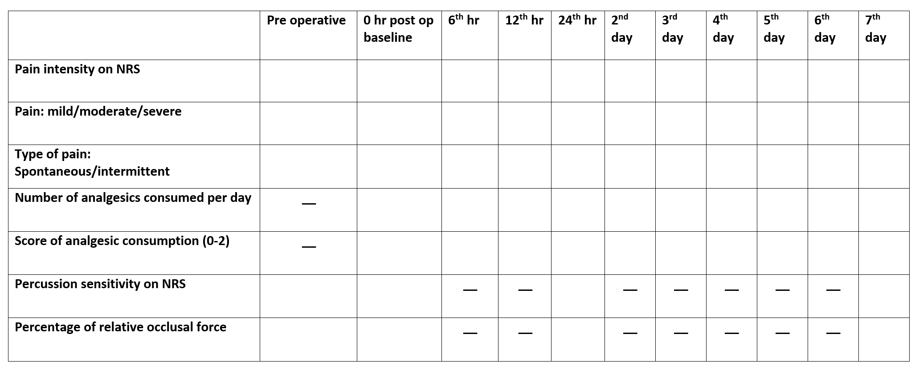

REFERENCES
1. Berman LH, Hargreaves KM. Cohen’s Pathways of the Pulp Expert Consult. 12th edition. Amsterdam: Elsevier; 2020.
2. Glickman GN. AAE Consensus Conference on Diagnostic Terminology: background and perspectives. J Endod. 2009 Dec;35(12):1619–20.
3. Ingle JI, Bakland LK, Baumgartner JC. Ingle’s endodontics 6. 6th ed. Hamilton, ON, Maidenhead: BC Decker ; McGraw-Hill Education [distributor]; 2008.
4. Ricucci D, Loghin S, Siqueira JF. Correlation between Clinical and Histologic Pulp Diagnoses. J Endod. 2014 Dec;40(12):1932–9.
5. Heyeraas KJ, Berggreen E. Interstitial Fluid Pressure in Normal and Inflamed Pulp. Crit Rev Oral Biol Med. 1999 Jun;10(3):328–36.
6. Paredes-Vieyra J, Enriquez FJJ. Success rate of single- versus two-visit root canal treatment of teeth with apical periodontitis: a randomized controlled trial. J Endod. 2012 Sep;38(9):1164–9.
7. Burns LE, Kim J, Wu Y, Alzwaideh R, McGowan R, Sigurdsson A. Outcome of primary root canal therapy: An updated systematic review of longitudinal clinical studies published between 2003 and 2020. Int Endod J. 2022 Jul;55(7):714–31.
8. AlRahabi MK. Predictors, prevention, and management of postoperative pain associated with nonsurgical root canal treatment: A systematic review. J Taibah Univ Med Sci. 2017 Oct;12(5):376–84.
9. Shamszadeh S, Shirvani A, Asgary S. Does occlusal reduction reduce post‐endodontic pain? A systematic review and meta‐analysis. J Oral Rehabil. 2020 Apr;47(4):528–35.
10. Juloski J, Radovic I, Goracci C, Vulicevic ZR, Ferrari M. Ferrule effect: a literature review. J Endod. 2012 Jan;38(1):11–9.
11. Nguyen‐Nhon D, Nagendrababu V, Pulikkotil SJ, Rossi‐Fedele G. Effect of occlusal reduction on postendodontic pain: A systematic review and meta‐analysis of randomised clinical trials. Aust Endod J. 2020 Aug;46(2):282–94.
12. Chagas Carvalho Alves N, Raiane Mamede Veloso S, De Andrade Silva S, De Almeida AC, Tavares Velozo Telles C, Romeiro K, et al. Influence of occlusal reduction on pain after endodontic treatment: a systematic review and meta-analysis. Sci Rep. 2021 Jul 7;11(1):14019.
13. Arslan H, Seckin F, Kurklu D, Karatas E, Yanikoglu N, Capar ID. The effect of various occlusal reduction levels on postoperative pain in teeth with symptomatic apical periodontitis using computerized analysis: a prospective, randomized, double-blind study. Clin Oral Investig. 2017 Apr;21(3):857–63.
14. Rosenberg PA, Babick PJ, Schertzer L, Leung A. The effect of occlusal reduction on pain after endodontic instrumentation. J Endod. 1998 Jul;24(7):492–6.
15. European Society of Endodontology (ESE) developed by:, Duncan HF, Galler KM, Tomson PL, Simon S, El‐Karim I, et al. European Society of Endodontology position statement: Management of deep caries and the exposed pulp. Int Endod J. 2019 Jul;52(7):923–34.
16. Lin LM, Ricucci D, Saoud TM, Sigurdsson A, Kahler B. Vital pulp therapy of mature permanent teeth with irreversible pulpitis from the perspective of pulp biology. Aust Endod J. 2020 Apr;46(1):154–66.
17. Taha NA, Abdulkhader SZ. Full Pulpotomy with Biodentine in Symptomatic Young Permanent Teeth with Carious Exposure. J Endod. 2018 Jun;44(6):932–7.
18. Asgary S, Eghbal MJ. The effect of pulpotomy using a Calcium-Enriched Mixture cement versus one-visit root canal therapy on postoperative pain relief in irreversible pulpitis: a randomized clinical trial. Odontology. 2010 Jul;98(2):126–33.
19. Taha NA, Al-khatib H. 4-Year Follow-up of Full Pulpotomy in Symptomatic Mature Permanent Teeth with Carious Pulp Exposure Using a Stainproof Calcium Silicate–based Material. J Endod. 2022 Jan;48(1):87–95.
20. Eghbal MJ, Haeri A, Shahravan A, Kazemi A, Moazami F, Mozayeni MA, et al. Postendodontic Pain after Pulpotomy or Root Canal Treatment in Mature Teeth with Carious Pulp Exposure: A Multicenter Randomized Controlled Trial. Pain Res Manag. 2020 Jun 30;2020:1–14.
21. Shallal-Ayzin M, Trinh T, Yeung W, Tawil PZ, Haggerty CL, Wu D, et al. A Prospective Analysis of the Correlation Between Postoperative Pain and Vital Pulp Therapy. Front Dent Med. 2021 Mar 23;2:647417.
22. Jostes JL, Holland GR. The effect of occlusal reduction after canal preparation on patient comfort. J Endod. 1984 Jan;10(1):34–7.
23. Creech JL, Walton RE, Kaltenbach R. Effect of occlusal relief on endodontic pain. J Am Dent Assoc. 1984 Jul;109(1):64–7.
24. Parirokh M, Rekabi AR, Ashouri R, Nakhaee N, Abbott PV, Gorjestani H. Effect of Occlusal Reduction on Postoperative Pain in Teeth with Irreversible Pulpitis and Mild Tenderness to Percussion. J Endod. 2013 Jan;39(1):1–5.
25. Qadeer S, Özcan M, Edelhoff D, Van Pelt H. Accuracy, Reliability and Clinical Implications of Static Compared to Quantifiable Occlusal Indicators. Eur J Prosthodont Restor Dent. 2021 Aug 31;29(3):130–41.
26. Emara RS, Abou El Nasr HM, El Boghdadi RM. Evaluation of postoperative pain intensity following occlusal reduction in teeth associated with symptomatic irreversible pulpitis and symptomatic apical periodontitis: a randomized clinical study. Int Endod J. 2019 Mar;52(3):288–96.
27. Ahmed YE, Emara RS, Sarhan SM, El Boghdadi RM, El‐Bayoumi MAA, El‐Far HMM, et al. Post‐treatment endodontic pain following occlusal reduction in mandibular posterior teeth with symptomatic irreversible pulpitis and sensitivity to percussion: a single‐centre randomized controlled trial. Int Endod J. 2020 Sep;53(9):1170–80.
28. Taha NA, Abdelkhader SZ. Outcome of full pulpotomy using Biodentine in adult patients with symptoms indicative of irreversible pulpitis. Int Endod J. 2018 Aug;51(8):819–28.
29. McHugh H, Wright PP, Peters CI, Peters OA. Diagnostic and Prognostic Predictors for the Success of Pulpotomy in Permanent Mature Posterior Teeth with Moderate to Severe Pulpitis: A Scoping Review. Oral. 2023 Nov 27;3(4):545–71.
30. Alhilou AM, Al-Moraissi EA, Bakhsh A, Christidis N, Näsman P. Pain after emergency treatments of symptomatic irreversible pulpitis and symptomatic apical periodontitis in the permanent dentition: a systematic review of randomized clinical trials. Front Oral Health. 2023 Oct 18;4:1147884.
31. Taha NA, Abuzaid AM, Khader YS. A Randomized Controlled Clinical Trial of Pulpotomy versus Root Canal Therapy in Mature Teeth with Irreversible Pulpitis: Outcome, Quality of Life, and Patients’ Satisfaction. J Endod. 2023 Jun;49(6):624-631.e2.
32. Downie WW, Leatham PA, Rhind VM, Wright V, Branco JA, Anderson JA. Studies with pain rating scales. Ann Rheum Dis. 1978 Aug;37(4):378–81.
33. Ørstavik D, Kerekes K, Eriksen HM. The periapical index: A scoring system for radiographic assessment of apical periodontitis. Dent Traumatol. 1986 Feb;2(1):20–34.
34. Sirintawat N, Sawang K, Chaiyasamut T, Wongsirichat N. Pain measurement in oral and maxillofacial surgery. J Dent Anesth Pain Med. 2017 Dec;17(4):253–63.
35. Galani M, Tewari S, Sangwan P, Mittal S, Kumar V, Duhan J. Comparative Evaluation of Postoperative Pain and Success Rate after Pulpotomy and Root Canal Treatment in Cariously Exposed Mature Permanent Molars: A Randomized Controlled Trial. J Endod. 2017 Dec;43(12):1953–62.
36. Taha NA, Albakri SW. Outcome and Prognostic Factors for Partial and Full Pulpotomy in the Management of Spontaneous Symptomatic Pulpitis in Carious Mature Permanent Teeth: A Randomized Clinical Trial. J Endod. 2024 Jul;50(7):889–98.
37. Owatz CB, Khan AA, Schindler WG, Schwartz SA, Keiser K, Hargreaves KM. The Incidence of Mechanical Allodynia in Patients With Irreversible Pulpitis. J Endod. 2007 May;33(5):552–6.

ANNEXURE-I
PARTICIPANT INFORMATION SHEET(PIS)

Title of the study: Effect of occlusal reduction on post operative pain and outcome of full pulpotomy performed in permanent mature mandibular molar teeth with symptomatic irreversible pulpitis and sensitivity to percussion.: A Randomized Clinical Trial
Aim of the study: To evaluate Effect of occlusal reduction on post operative pain and outcome of full pulpotomy performed in permanent mature mandibular molar teeth with symptomatic irreversible pulpitis and sensitivity to percussion: A Randomized Clinical Trial.
Method of study:
You have a decayed tooth that is the cause for your pain. An x-ray will be taken. If you match the inclusion criteria and agree to participate, you will be included in the study. You will be given an injection in the mouth to numb the tooth. After that, the decay will be removed using instruments. Then the diseased portion of the pulp will be removed. Thereafter, a medicament will be placed over the remaining healthy pulp. The tooth will be restored with the permanent filling material.

Expected duration of subject participation:
The expected duration of the participation is 12 months, Participant will be recalled on 1st day, 7th day, 3rd month, 6th month and 12th month post-operatively.

The benefits to be expected from the research to the subject or to others:
The present study is in line with minimally invasive endodontics in which only diseased part will be removed and healthy part will be preserved. The aim of the present study is to evaluate and compare effect of occlusal reduction on post operative pain after full pulpotomy performed in permanent mature mandibular molar teeth with symptomatic irreversible pulpitis and sensitivity to percussion, which will give a clear idea about outcome occlusal reduction as method for post-operative pain management. In addition, it would help the scientific community and mankind at large.

Any risk to the subject associated with the study:
These individual procedures are routinely done procedure in the department. We do not anticipate any risk due to the study per se. However, management of any adverse events developed during this study will be done as per the protocol followed at the Division of Conservative Dentistry and Endodontics, CDER, AIIMS.
Maintenance of confidentiality of records:
Your personal data (personal information, radiographs, medical history etc.) recorded for the purpose of the study will be kept confidential and they will only be used for academic purpose with prior information and the identity will not be revealed.
Provision of free treatment for research related injury:
There is no chance of any injury during the research related procedure. There is no risk of injury, disability or death associated with the study.
No compensation will be provided.
Freedom of the individual to participate and to withdraw from research at any time, without penalty or loss of benefits to which the subject would otherwise be entitled:
Participation in the study is voluntary. You are free to refuse or withdraw your consent or to discontinue your participation in this study at any time, without jeopardizing your continuing care at CDER, AIIMS.
Amount of blood sample to be taken (in a teaspoon full):
No sample will be collected for this study.
Costs and sources of investigations, disposables, implants and drugs/contrast media:
You will be exempted from the charges for treatment/investigations during the research and the investigator will bear all the costs for the same.
Contacts:
If at any time you feel that you are not informed properly regarding the risk and benefits or others related to the study or have any other queries, you can contact the following:
Dr.Nisarg Dalal
Ph no: 7046028022
Academic Junior Resident
Division of Conservative Dentistry and Endodontics,
Centre for Dental Education and Research,
All India Institute of Medical Sciences, New Delhi-110029.
Dr. Amrita Chawla
Ph no: 987144552
Additional Professor
Division of Conservative Dentistry and Endodontics,
Centre for Dental Education and Research,
All India Institute of Medical Sciences, New Delhi-110029
अनुबंध-I
आंशिक सूचना पत्रक (पीआईएस)
अध्ययन का शीर्षक: लक्षणात्मक अपरिवर्तनीय पल्पिटिस और पर्क्यूशन के प्रति संवेदनशीलता के साथ परिपक्व स्थायी मैंडिबुलर मोलर दांतों में किए गए पूर्ण पल्पोटॉमी के बाद पोस्ट ऑपरेटिव दर्द पर ऑक्लूसल कमी का प्रभाव।: एक यादृच्छिक नैदानिक ​​परीक्षण
अध्ययन का उद्देश्य: लक्षणात्मक अपरिवर्तनीय पल्पिटिस और पर्क्यूशन के प्रति संवेदनशीलता के साथ परिपक्व स्थायी मैंडिबुलर मोलर दांतों में किए गए पूर्ण पल्पोटॉमी के बाद पोस्ट ऑपरेटिव दर्द पर ऑक्लूसल कमी के प्रभाव का मूल्यांकन करना।: एक यादृच्छिक नैदानिक ​​परीक्षण।
अध्ययन की विधि:
आपके पास एक सड़ा हुआ दांत है जो आपके दर्द का कारण है। एक एक्स-रे लिया जाएगा। यदि आप समावेशन मानदंडों से मेल खाते हैं और भाग लेने के लिए सहमत हैं, तो आपको अध्ययन में शामिल किया जाएगा। दांत को सुन्न करने के लिए आपको मुंह में एक इंजेक्शन दिया जाएगा। उसके बाद, उपकरणों का उपयोग करके सड़ांध को हटा दिया जाएगा। फिर पल्प के रोगग्रस्त हिस्से को हटा दिया जाएगा। उसके बाद, शेष स्वस्थ पल्प पर एक दवा रखी जाएगी। दांत को स्थायी भरने वाली सामग्री के साथ बहाल किया जाएगा।
विषय भागीदारी की अपेक्षित अवधि:
भागीदारी की अपेक्षित अवधि 12 महीने है, प्रतिभागी को ऑपरेशन के बाद पहले दिन, 7वें दिन, तीसरे महीने, 6वें महीने और 12वें महीने में वापस बुलाया जाएगा।
शोध से विषय या अन्य लोगों को मिलने वाले लाभ:
वर्तमान अध्ययन न्यूनतम इनवेसिव एंडोडोंटिक्स के अनुरूप है जिसमें केवल रोगग्रस्त भाग को हटाया जाएगा और स्वस्थ भाग को संरक्षित किया जाएगा। वर्तमान अध्ययन का उद्देश्य लक्षणात्मक अपरिवर्तनीय पल्पिटिस और पर्क्यूशन के प्रति संवेदनशीलता के साथ परिपक्व स्थायी मैंडिबुलर मोलर दांतों में पूर्ण पल्पोटॉमी के बाद पोस्ट ऑपरेटिव दर्द पर ओक्लूसल रिडक्शन के प्रभाव का मूल्यांकन और तुलना करना है, जो पोस्ट-ऑपरेटिव दर्द प्रबंधन के लिए विधि के रूप में ओक्लूसल रिडक्शन के परिणाम के बारे में स्पष्ट विचार देगा। इसके अलावा, यह वैज्ञानिक समुदाय और बड़े पैमाने पर मानव जाति की मदद करेगा।
अध्ययन से जुड़े विषय पर कोई जोखिम:
इन व्यक्तिगत प्रक्रियाओं को विभाग में नियमित रूप से किया जाता है। हम प्रति अध्ययन के कारण किसी भी जोखिम का अनुमान नहीं लगाते हैं । हालांकि, इस अध्ययन के दौरान विकसित किसी भी प्रतिकूल घटनाओं का प्रबंधन प्रोटोकॉल के अनुसार रूढ़िवादी दंत चिकित्सा और एंडोडोंटिक्स विभाग, CDER, AIIMS के बाद किया जाएगा।
अभिलेखों की गोपनीयता का रखरखाव:
अध्ययन के उद्देश्य के लिए आपके व्यक्तिगत डेटा (व्यक्तिगत जानकारी, रेडियोग्राफ़, मेडिकल इतिहास आदि) को गोपनीय रखा जाएगा और उनका उपयोग केवल पूर्व सूचना के साथ शैक्षणिक उद्देश्य के लिए किया जाएगा और पहचान का खुलासा नहीं किया जाएगा।
अनुसंधान से संबंधित चोट के लिए मुफ्त उपचार का प्रावधान:
अध्ययन से जुड़े चोट, विकलांगता या मृत्यु का कोई जोखिम नहीं है।
किसी व्यक्ति को किसी भी समय अनुसंधान से भाग लेने और अनुसंधान से पीछे हटने की स्वतंत्रता, बिना किसी दंड या लाभ के नुकसान जिसके विषय अन्यथा हकदार होंगे:
अध्ययन में भागीदारी स्वैच्छिक है। CDER, AIIMS में आपकी निरंतर देखभाल को खतरे में डाले बिना, आप किसी भी समय इस अध्ययन में अपनी सहमति देने से इनकार करने या अपनी भागीदारी को बंद करने के लिए स्वतंत्र हैं।
ली जाने वाली रक्त की मात्रा
इस अध्ययन के लिए कोई नमूना एकत्र नहीं किया जाएगा।
लागत और जांच के स्रोत, डिस्पोजल, प्रत्यारोपण और ड्रग्स / कंट्रास्ट मीडिया:
आपको अनुसंधान के दौरान उपचार / जांच के लिए शुल्क से छूट दी जाएगी और जांचकर्ता उसी के लिए सभी लागतों को वहन करेगा।
संपर्क:
यदि किसी भी समय आपको लगता है कि आपको अध्ययन से संबंधित जोखिम और लाभों या अन्य के बारे में ठीक से सूचित नहीं किया गया है या कोई अन्य प्रश्न हैं, तो आप निम्नलिखित से संपर्क कर सकते हैं:
डॉ. निसर्ग दलाल
फोन नं. : 7046028022
अकादमिक जूनियर रेजिडेंट
कंज़र्वेटिव डेंटिस्ट्री और एंडोडोंटिक्स विभाग,
डेंटल एजुकेशन एंड रिसर्च सेंटर,
अखिल भारतीय आयुर्विज्ञान संस्थान, नई दिल्ली-110029
डॉ. अमृता चावला
फोन नं. : 987144552
अतिरिक्त प्रोफेसर
कंज़र्वेटिव डेंटिस्ट्री और एंडोडोंटिक्स विभाग,
डेंटल एजुकेशन एंड रिसर्च सेंटर,
अखिल भारतीय आयुर्विज्ञान संस्थान, नई दिल्ली-110029

ANNEXURE - II
PARTICIPANT INFORMED CONSENT FORM
Patient Id No. for this trial: _______________________
Project Title: Effect of occlusal reduction on post operative pain and outcome of full pulpotomy performed in permanent mature mandibular molar teeth with symptomatic irreversible pulpitis and sensitivity to percussion: A Randomized Clinical Trial
Name of Principal Investigator: Dr. Nisarg Dalal Tel. No. 7046028022
Name of Guide: Dr. Amrita Chawla Tel. No. 987144552
The content of information sheet dated ________ (version) ___________ that was provided have been read carefully by me/explained to me in detail to me, in a language that I comprehend and have fully understood the contents. I confirm that I have had opportunity to ask questions.
The nature and purpose of study and its potential risks/ benefits and expected duration of study, and relevant details of study have been explained to me in detailed. I understand that my participation is voluntary and that I am free to withdraw at any time without giving any reasons, without my medical care for legal rights being affected.
I understand that information collected about me from my participation in this research and section of any of my medical notes may be looked at by responsible individuals from AIIMS.
I give permission for these individuals to have assess my records. I agree to take part in above study.
Signature/left thumb impression: ______________ |  | Date: ___________
Name of the Patient: _____________________  Son/Daughter/Spouse of: __________________  Postal Address: _________________________  ___________________________ |  | Place: ___________
This is to certify that above consent has been obtained in my presence.
Signature of Principal Investigator |  | Date: ________
 |  | Place: ________
Witness 1) |  | Witness 2)
Name of the Witness: ________________ |  | Name of the Witness: _______________
Postal Address: ________________ |  | Postal Address: ____________________
__________________________________ |  | _________________________________
Tel. ____________________________ |  | Tel. ___________________________
अनुबंध-II
आंशिक सूचित सहमति फार्म
इस परीक्षण के लिए रोगी आईडी संख्या: _______________________

परियोजना शीर्षक: लक्षणात्मक अपरिवर्तनीय पल्पिटिस और टक्कर के प्रति संवेदनशीलता के साथ परिपक्व स्थायी मैंडिबुलर दाढ़ के दांतों में पूर्ण पल्पोटॉमी के बाद पोस्ट ऑपरेटिव दर्द पर ओक्लूसल कमी का प्रभाव।: एक यादृच्छिक नैदानिक ​​परीक्षण
प्रमुख अन्वेषक का नाम: डॉ. निसर्ग दलाल तेल। क्रमांक 7046028022
मार्गदर्शक का नाम: डॉ. अमृता चावला तेल। क्रमांक 987144552

दी गई सूचना पत्र की सामग्री ________ (संस्करण) ___________ जो मुझे प्रदान की गई है, मुझे मेरे द्वारा ध्यान से पढ़ी गई / मुझे विस्तार से बताई गई है, उस भाषा में जिसे मैं समझती हूं और सामग्री को पूरी तरह से समझ चुकी हूं। मैं पुष्टि करता हूं कि मुझे सवाल पूछने का अवसर मिला है।
अध्ययन की प्रकृति और उद्देश्य और इसके संभावित जोखिम / लाभ और अध्ययन की अपेक्षित अवधि, और अध्ययन के प्रासंगिक विवरण मुझे विस्तृत रूप से समझाया गया है। मैं समझता हूं कि मेरी भागीदारी स्वैच्छिक है और मैं बिना किसी कारण के किसी भी समय वापस लेने के लिए स्वतंत्र हूं, बिना कानूनी अधिकारों के मेरी चिकित्सा प्रभावित हुई है।
मैं समझता हूं कि इस शोध में मेरी भागीदारी से मेरे बारे में एकत्र की गई जानकारी और मेरे किसी भी मेडिकल नोट के अनुभाग को एम्स के जिम्मेदार व्यक्तियों द्वारा देखा जा सकता है।
मैं इन व्यक्तियों को अपने रिकॉर्ड का आकलन करने की अनुमति देता हूं। मैं उपरोक्त अध्ययन में भाग लेने के लिए सहमत हूं।

हस्ताक्षर / बाएं अंगूठे का निशान: ______________ |  | तारीख: ___________
रोगी का नाम: _____________________  पुत्र / पुत्री / पति / पत्नी: __________________  डाक का पता: _________________________  ___________________________ |  | जगह: ___________

यह प्रमाणित करना है कि मेरी उपस्थिति में उपरोक्त सहमति प्राप्त की गई है।

प्रधान अन्वेषक का हस्ताक्षर |  | तारीख: ________
 |  | जगह: ________
गवाह 1) |  | साक्षी 2)
गवाह का नाम: ________________ |  | गवाह का नाम: _______________
डाक का पता: ________________ |  | डाक का पता: ____________________
__________________________________ |  | _________________________________
तेल। ____________________________ |  | तेल। ___________________________

